Applicant Guidance Notes


DBS Online Disclosure Guide (eBulkPlus)

Contents
Applicant Guidance Notes 2
Logging onto the System 3
Statement of Fair Processing 4
Application Pre-entry Statement 5
Section 1 – About You 6
Section 2 – Address History 7
Section 3 – Additional Info 8
Section 4 – Employment Details 9
Section 5 – Confirmation and Consent 10
Complete Application 11
DBS List of Acceptable Identification 12

Applicant Guidance Notes

An online DBS check can be completed by accessing the internet from any device that has this facility. This includes a smart phone, tablet, laptop or PC. It is supported on the latest versions of all modern browsers; however, we do not recommend access via Internet Explorer as this browser is unsupported both by our technology and soon by Microsoft also. If you do not own your own computer, you can go to any internet café or local library. Please be aware that you must complete your application form in full as part completed applications form cannot be saved.

Starting your application

You can start your application one of two ways depending on how you have been invited by the employer requesting this check to be carried out on you.
Option 1 – via a direct link within an email invitation
If you have received an email invitation containing a direct link to completing your application, simply click the link contained in your email and skip to page 4 of this guide.

Option 2 – accessing our system through your browser
Please enter the following address in the web browser:
https://matrixscreening.com/xxxxx
If you are not taken directly to the ‘Start New Application’ page, please click on ‘Start Application’ in the white box entitled ‘Standard / Enhanced DBS Application’ to enter the system and start your application.
Please note at this stage of the process your login details are case sensitive.
- Enter the Organisation Reference that has been supplied to you by the company that you will be/are working for.
- Enter the Organisation Code that has been supplied to you by the company that you will be/are working for.

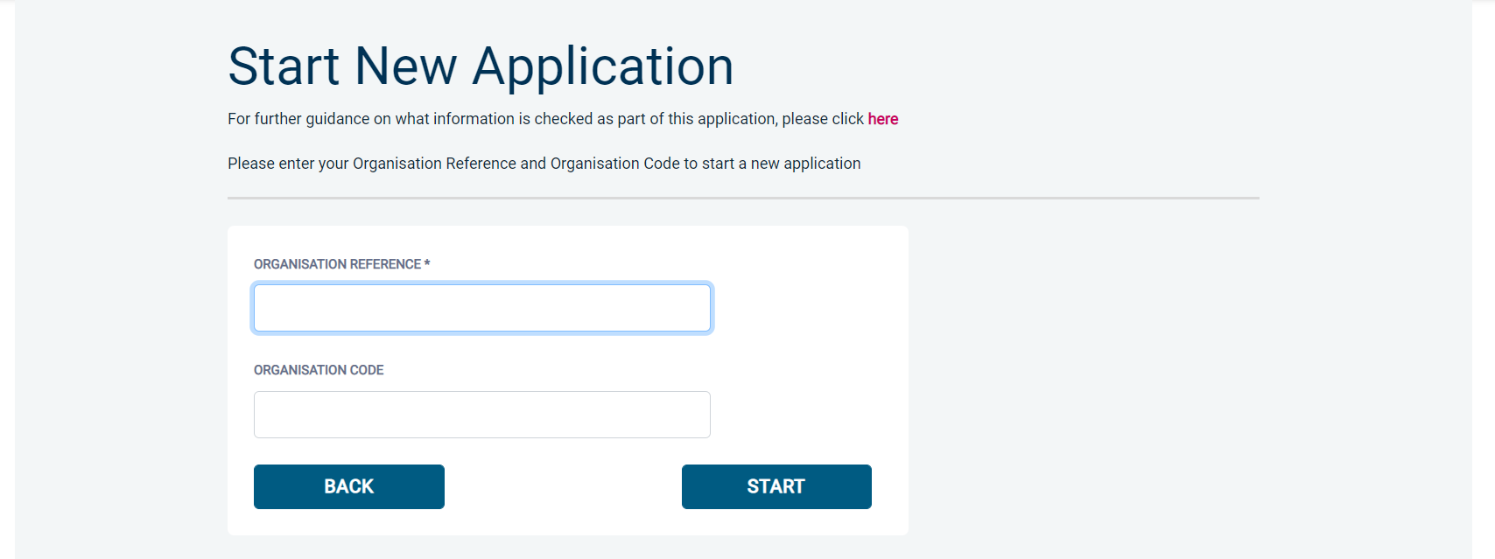

Once you have completed this section click ‘Enter’.

Statement of Fair Processing

You will now be taken to the ‘eBulkPlus Statement of Fair Processing’ outlining the terms and conditions. Please read the statement and tick the box to confirm this has been read and agreed to.


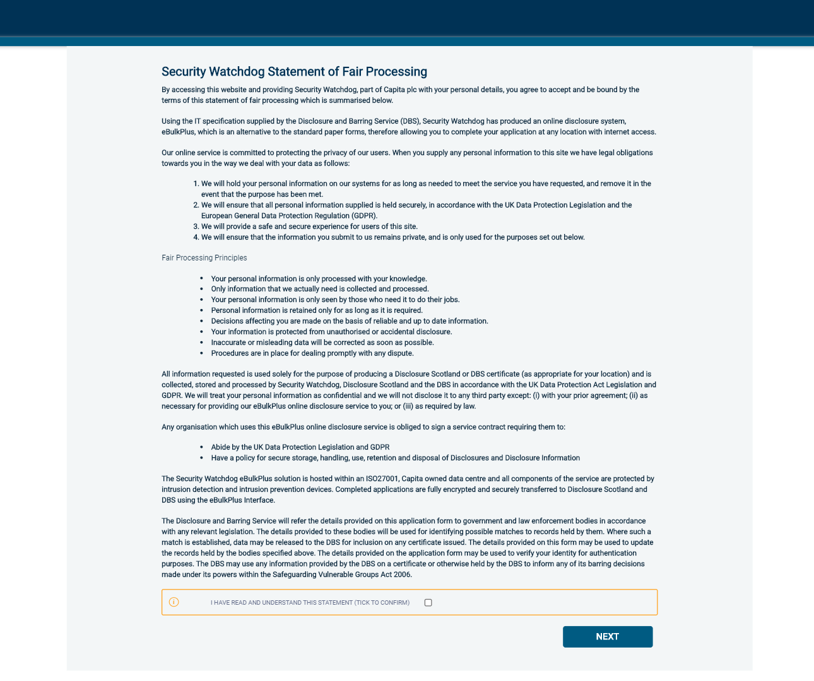

Once you have ticked the consent box please click ‘Next’

Application Pre-entry Statement

You will now see the application pre-entry statement; this gives concise information in regards to the requirements by the DBS regarding acceptable identification in support of your DBS application.

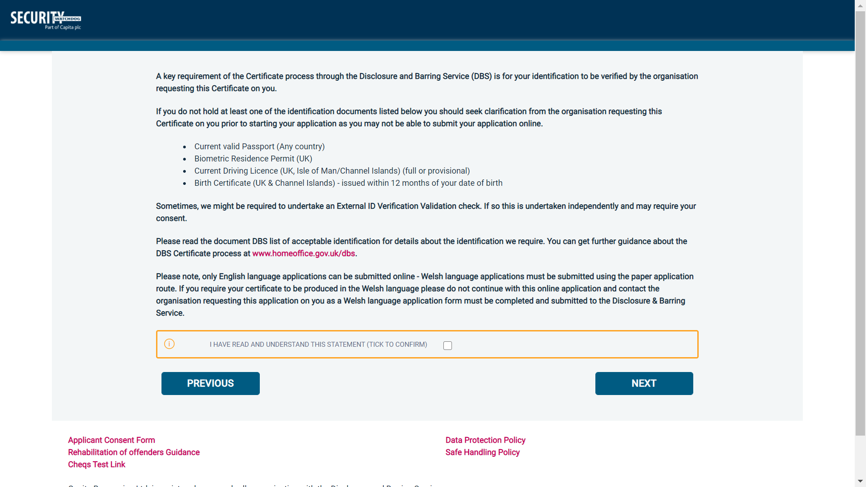

Once you have ticked the consent box please click ‘Next’

- The application form is a simple 5 step process. Please complete all fields.
- Mandatory fields are denoted by (*)

Mistakes on the application form will cause delays in processing.

Section 1 – About You

Third Party Details
If you are completing the application on behalf of someone else, please ensure you answer ‘Yes’ to the first question within the ‘Third Party Details’ section. Please then provide your personal details within the ‘Third Party Details’ section but the details of the person you are completing it on behalf of, for the rest of the application.
Applicant’s Details
Please enter your personal details.
If you have any middle name(s) ensure that you enter these details, particularly those that appear on your identity documents, e.g. passport, driving licence, birth certificate, etc. Any missing information from this or any other section can severely delay the processing of your criminal record check.

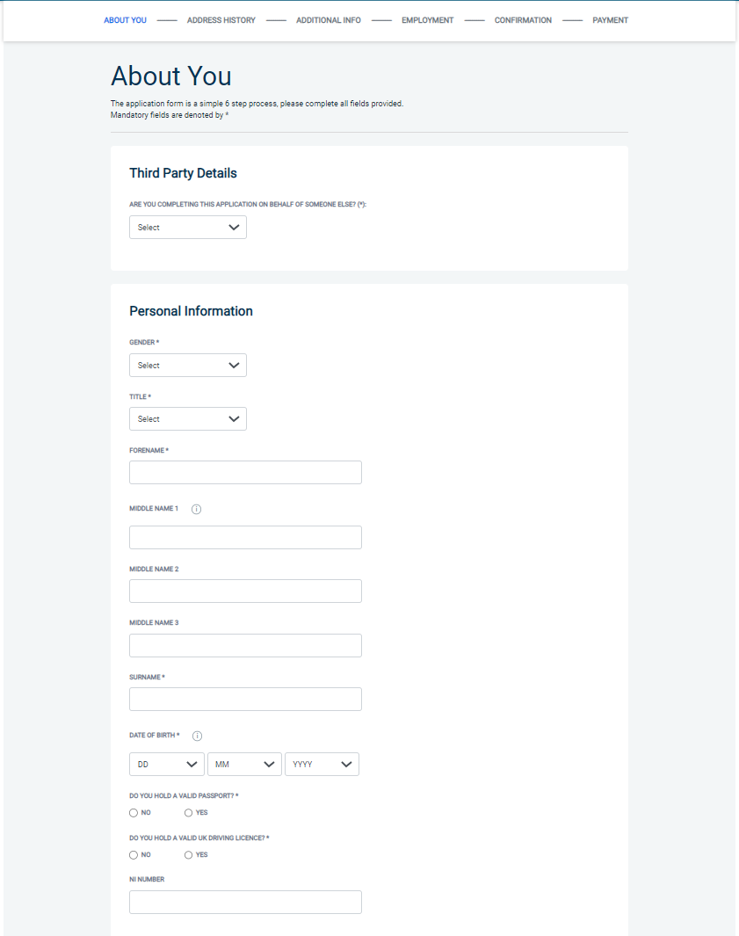

Once you have completed this section click ‘Next’.

Section 2 – Address History

Please enter your current address either using the address lookup tool or manually. If you have not lived at this property for more than five years, you will be taken to another screen. Here you will be required to add any additional addresses to ensure your address history goes back the required five years. Please note if you do not provide a minimum of five years address history, you will not be able to proceed to the next stage of the application process.

Address Dates
There cannot be any gaps in your address history, however overlaps are allowed. Please ensure that the month and year of each address follows that of the previous address where relevant. Students who switch between their permanent residence and education establishments can enter their permanent residence as their main address and enter education addresses that overlap the main address. Once an address has been entered, you can edit any information by clicking on the ‘Edit’ button.

Postcode
Please ensure that all UK addresses have a full postcode; if you cannot remember your postcode please use the address lookup tool to populate the address by searching using the first line of your address.

No Fixed Abode UK
If you were of no fixed abode within the UK please enter the nearest hostel address to the location you were based.

Foreign Addresses/Travelling Overseas
If you have travelled overseas and cannot supply the address for a foreign country then please enter ‘no fixed abode’ for Address Line 1. Please then enter the Town/City and Country of where you were residing within this period.

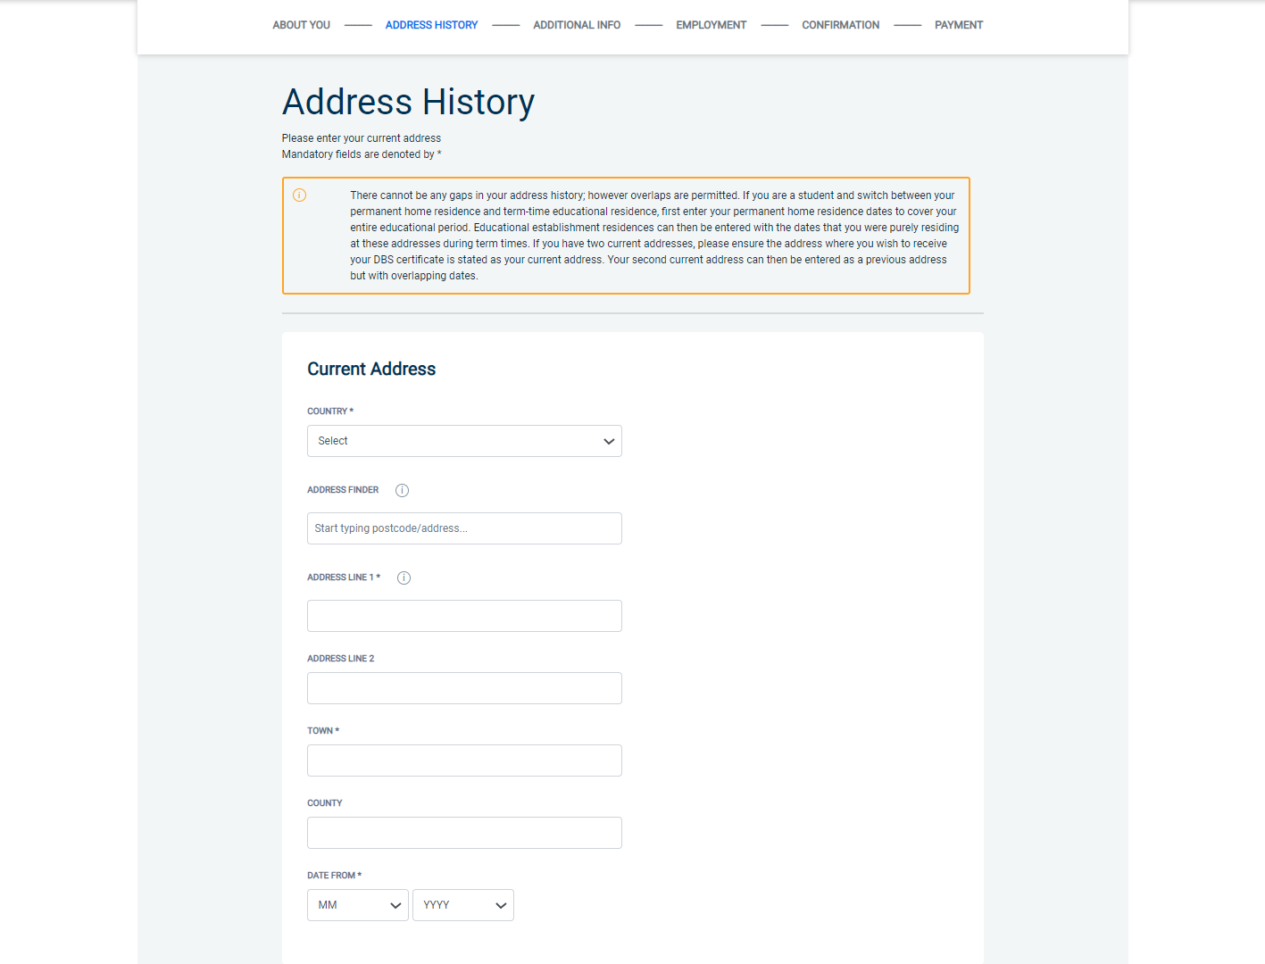

Once you have completed this section click ‘Next’.

Section 3 – Additional Info

Place of Birth
Please enter details of your place of birth.

Nationality at Birth
Please enter your Nationality at birth and state YES or NO as to whether this has changed since you were born. If this has changed, you will be required to enter your current nationality.

Changed Surname
If you have changed your surname please provide your birth surname and the year you changed it. Please ensure that where names change they run in date order and with no gaps.

Other Names
Please provide details of any other names used at any time during your lifetime and the dates during which the names were used. Please enter each forename, middle name(s) and surname separately using the 'Add Name' button below. If you have used any aliases, e.g. William known as Bill, please also supply these details.
Failure to supply any additional information may cause your application to be delayed.

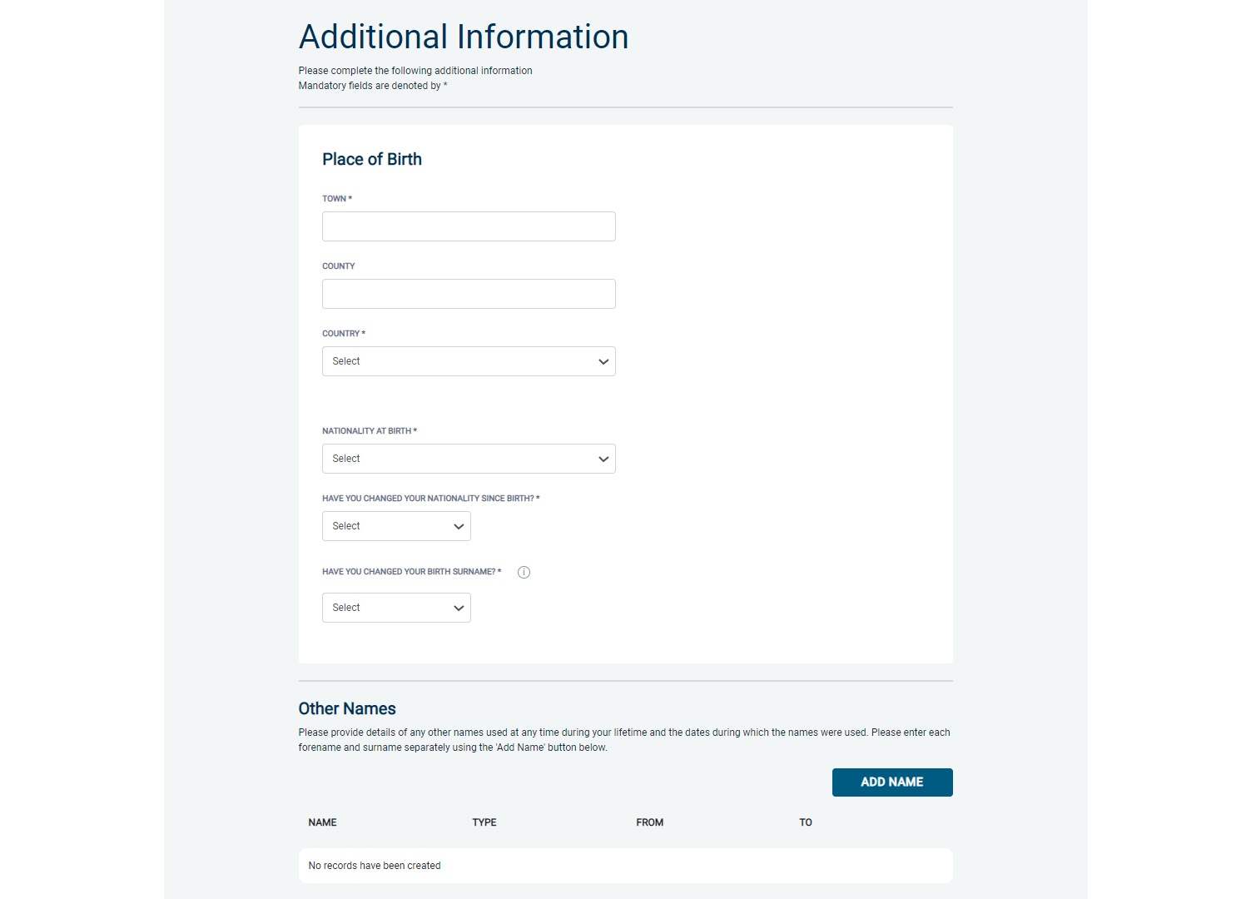

Once you have completed this section click ‘Next’.

Section 4 – Employment Details

Position Applied For
Please insert the correct job role as supplied to you by your current/new employer. You will either be required to select your job role from the dropdown list provided or enter this manually. No abbreviations are permissible, e.g. Admin Asst should read Administrative Assistant. If you are a volunteer do not enter just volunteer, please enter in which capacity your job role is, e.g. Coach.
Failure to enter the correct job role may cause your application to be delayed.

Employer Name
This has been defaulted to the organisation you are applying through and should not be amended.

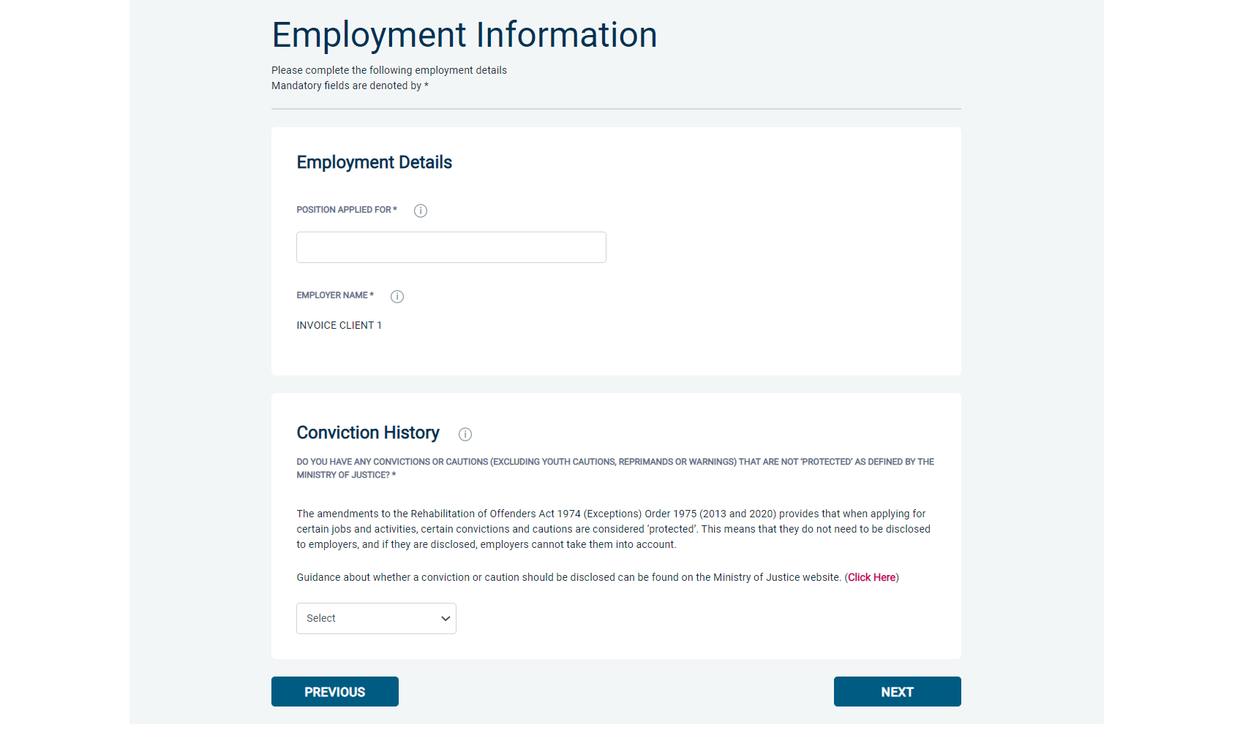

Conviction History
If you have never been convicted of a criminal offence or received a caution, then please select ‘No’. If you have been convicted of a criminal offence or received a caution (excluding youth cautions, reprimands or warnings) that are ‘protected’ as defined by the Rehabilitation of Offenders Act then please also select ‘No’.
If you have ever been convicted of a criminal offence or received a caution (excluding youth cautions, reprimands or warnings) that is not ‘protected’ as defined by the Rehabilitation of Offenders Act then please select ‘Yes’.
For more information, please refer to:
https://www.gov.uk/government/publications/new-guidance-on-the-rehabilitation-of-offenders-act-1974

Once you have completed this section click ‘Next’.

Section 5 – Confirmation and Consent

Now please read through your application to ensure that there are no omissions/errors before you submit your application. If you wish to edit a section of your application click on ‘edit’ next to the section of the form that requires changes.
At the end of the application please make sure that you complete the Applicant Consent section.
This has been defaulted to the organisation you are applying through and should not be amended.

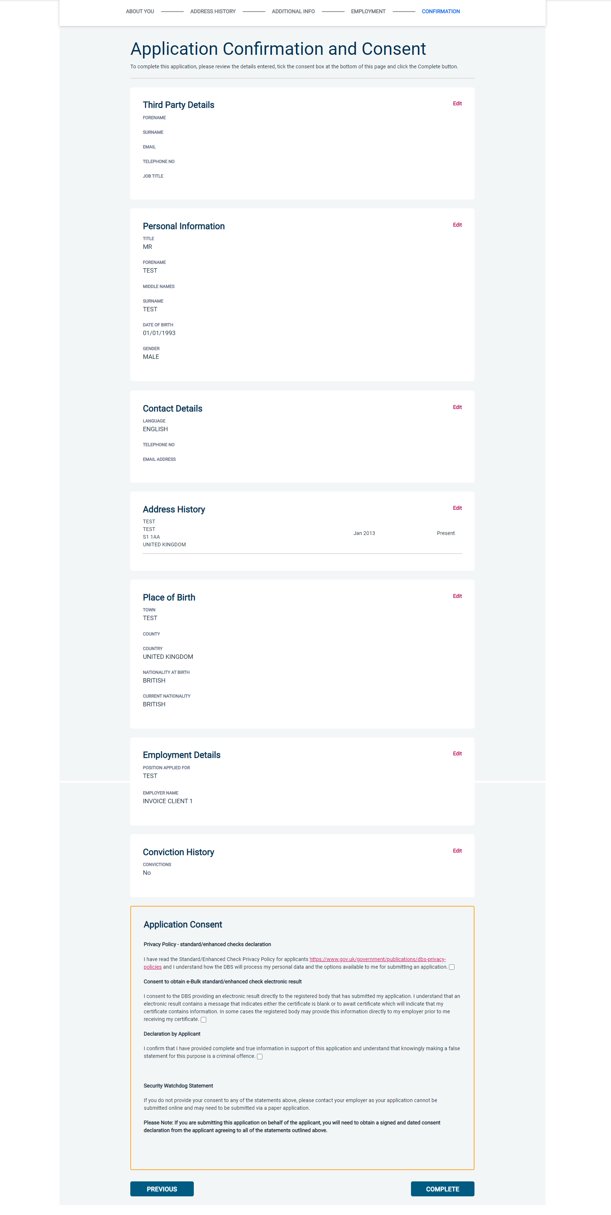

Now click ‘Complete’.

Complete Application

You have now completed your application form and you will be given a submission reference number. Please make a note of this number for reference purposes. If you entered an email address onto your application form you will receive a confirmation email containing these details.

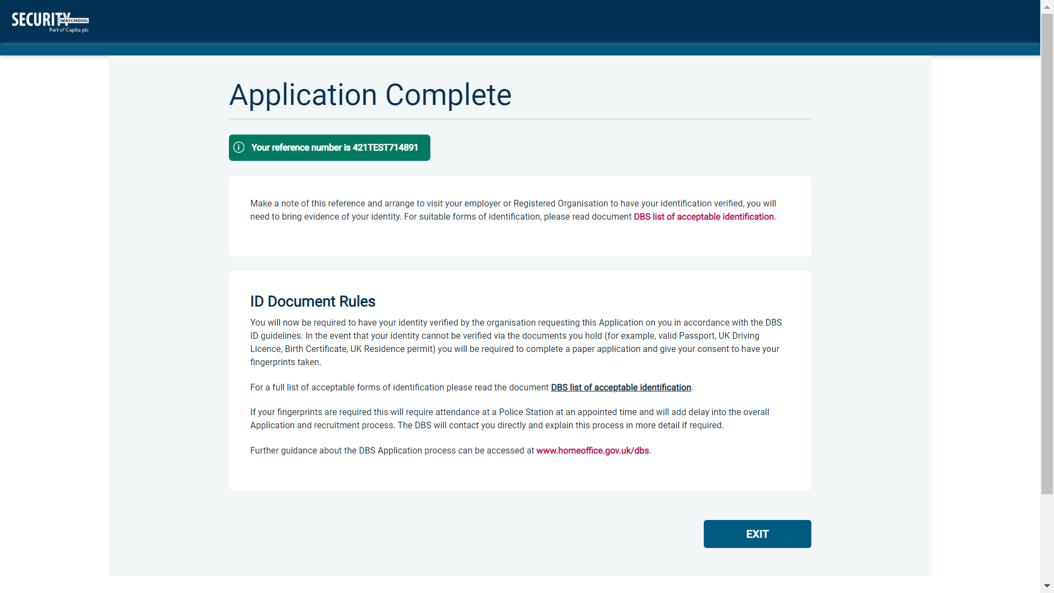

Your application form will be processed by your employer once they have verified your identity. Please see below for guidance on identity verification.

Next step - identity verification
In line with the DBS code of practice all applicants requiring a DBS check must have their identity verified.

How do I have my identity verified?
There are two ways in which your identity can be verified, either digitally and remotely via our certified identity service provider (IDSP) or by providing original identification to your employer. Your employer will inform you how they wish to verify your identity. If you are verifying your identity digitally, you will receive a unique link by email to upload your documents and a selfie to our IDSP platform. If you are verifying your identity manually, please provide original identification to your Company’s Nominated Person (usually Recruitment or HR Manager) and provide identification as listed in the acceptable ID table (see table below). Your application form will be processed by your employer once they have verified your identity, and then sent onto the DBS.

Tracking the progress of your application with the DBS
If you supplied an email address whilst entering your application, as soon as your application has been received at the DBS and is assigned a DBS Application Reference number you will receive a second email detailing this information. This email will also include details and links to the DBS website to enable you to track the progress of your application from the moment the disclosure process commences.

CONTACT DETAILS
Please contact XXX if you have any queries regarding the DBS application process. If you experience any technical issues with the online system, please contact XXX. Lines open 9.00am-5.30pm Monday to Friday. Alternatively, you can contact us by e-mail at XXX

DBS List of Acceptable Identification

Route 2
(3 documents to be seen plus an External ID Check)

1 document from Group 2a.
2 further documents from Group 2a or 2b.

Combination of documents must confirm name & DOB.

If unable to satisfy Route 2, proceed to Route 3/Fingerprints.

Route 1
(3 documents to be seen)

1 document from Group 1.
2 further documents from Group 1, 2a or 2b

Combination of documents must confirm name & DOB.

If unable to satisfy Route 1, proceed to Route 2/Fingerprints.
Route 3
(5 documents to be seen)

A UK Birth Certificate issued after birth.
4 further documents, 1 from Group 2a, 3 from 2a or 2b.

Combination of documents must confirm name & DOB.

If unable to satisfy Route 3, proceed to Fingerprints.

Fingerprints

Paper application form required (unable to process online).

Attendance at a local Police Station for fingerprints to be taken.

Group 1
Primary Identity Documents
- Current valid Passport
- Biometric Residence Permit (UK)
- Current Driving Licence – photo card (UK / Isle of Man / Channel Islands) (Full or Provisional)
- Birth Certificate (UK / Isle of Man / Channel Islands) (Issued within 12 months of birth)
Full or short form acceptable including those issued by UK authorities overseas, such as Embassies, High Commissions & HM Forces. (Photocopies are not acceptable)
- Adoption Certificate (UK / Channel Islands)
- eVisa - Accessed via the 'View and Prove' service
- Application Registration Card (ARC) – Issued by the Home Office

Group 2a  Trusted Government Documents | Group 2b  Financial & Social History Documents
- Current Driving Licence – photo card only (All Countries except Group 1) (Full or Provisional)  - Current Driving Licence – paper version (UK / Isle of Man / Channel Islands) (Full or Provisional)  - Birth Certificate (UK / Isle of Man / Channel Islands) (Issued after the time of birth)  - Marriage / Civil Partnership Certificate (UK / Channel Islands)  - HM Forces ID Card (UK)  - Fire Arms Licence (UK / Isle of Man / Channel Islands)  - Immigration document, work permit or VISA (Issued outside of UK) (Valid only for roles whereby applicant is living and working outside of UK.) | - Mortgage Statement (UK) **  - Bank/Building Society Statement (UK / Channel Islands) *  Monzo statements or statements printed from the internet are not acceptable  - Bank/Building Society Account Opening Confirmation Letter (UK) *  - Credit Card Statement (UK) *  - Financial Statement e.g. pension, endowment, ISA (UK) **  - P45/P60 Statement (UK / Channel Islands) **  - Council Tax Statement (UK / Channel Islands) **  - Utility Bill (UK) - Not Mobile Phone *  - Benefit Statement (UK) e.g. Child Allowance, Pension **  - Document from Central/ Local Government/ Government Agency/ Local Authority giving entitlement (UK / Channel Islands) *  e.g. DWP, Employment Service, HMRC, Job Centre, Social Security  - EEA National ID Card – must be valid  - Cards carrying the PASS accreditation logo (UK / Isle of Man / Channel Islands) – must be valid  - Irish Passport Card – must be valid (Cannot be used with an Irish Passport)  - Letter from Head Teacher or College Principal (16-19 year olds in full time education in the UK)  - Non-UK Bank/Building Society Statement *  Branch must be located in the country in which the applicant lives and works  - Letter of Sponsorship from future employer  Non-UK only – valid only for applicants residing outside UK at time of application  - HMRC self-assessment letters/tax demand letter (UK) **  - Valid European Health Insurance Card (EHIC) / Global Health Insurance Card (GHIC) (UK)
Please note if a document in the List of Valid Identity Documents is:
- Denoted with * - issued in the last 3 months
- Denoted with ** - issued in the last 12 months

