Primary Applicant Manager Guidance Notes

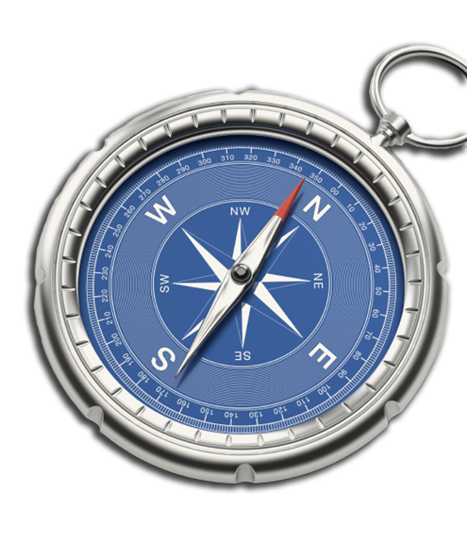
DBS Online Disclosure Guide (eBulkPlus)

Contents
Applicant Manager Guidance Notes 3
Logging onto the System 3
Inviting an applicant to submit their application 6
How to track/chase invitations 8
How to verify ID & Complete Section Y 10
What you must do as part of the ID Checking process 18
DBS Processing 21
Completed Results 22
Find an Application 27
Reports 28
DBS List of Acceptable Identification 30

Primary Applicant Manager Guidance Notes

Our online DBS and digital Right to Work checks can be completed by accessing the internet from any device that has this facility. This includes a smart phone, tablet, laptop or PC. It is supported on the latest versions of all modern browsers; however, we do not recommend access via Internet Explorer as this browser is unsupported both by our technology and soon by Microsoft also. The software is simplistic and easy to use. You can gain access to the system within minutes.

You have been granted access to eBulkPlus in the role of a Primary Applicant Manager. A Primary Applicant Manager can view and edit all applications created under the organisation or specific division they have been created under. A Primary Applicant Manager can stipulate what ID has been seen in relation to an applicant and complete Section Y details. After an applicant’s ID has been verified and Section Y completed, a Primary Applicant Manager has the authority to approve an application for countersigning.

Logging onto the System

Please enter the following address into your web browser:

https://matrixscreening.com/xxxxx

You will now be on the main login page that shows three white boxes. Please note at this stage of the process, your login details are case sensitive.

- Click on ‘Application Management’.
- Enter your company Organisation Reference - this will have been supplied to you in an automated email (if you cannot remember this please click on the ‘Forgotten your login details?’ icon at the bottom of the screen to be sent a reminder).
- Enter your Username.
- Enter your Date of Birth (for first initial login please ensure you enter the default date of birth 01 Jan 1998. Failure to do so will deny you access to the system).

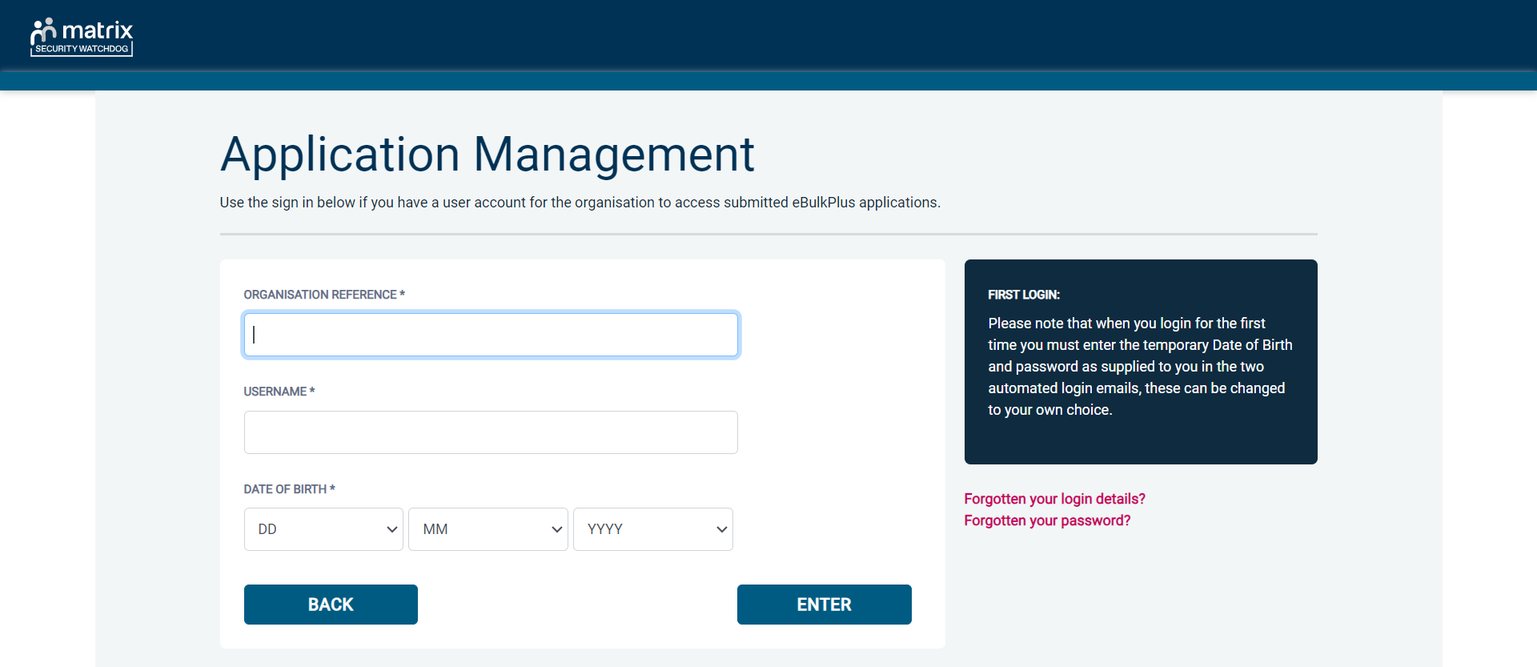
Screen Shot 1

- Once you have completed this section click ‘Enter’.

- Enter your password (this will be supplied to you in an automated email) – see screen shot 2 below (If you cannot remember this please click on the ‘Forgotten your password?’ icon at the bottom of the screen to be sent a new one-time password).

If you have difficulty gaining access to the system, please contact XXX however please ensure the first time you login that you have not been denied access because of entering your own date of birth. The first time you login you must enter the temporary default date of birth 01 Jan 1998.

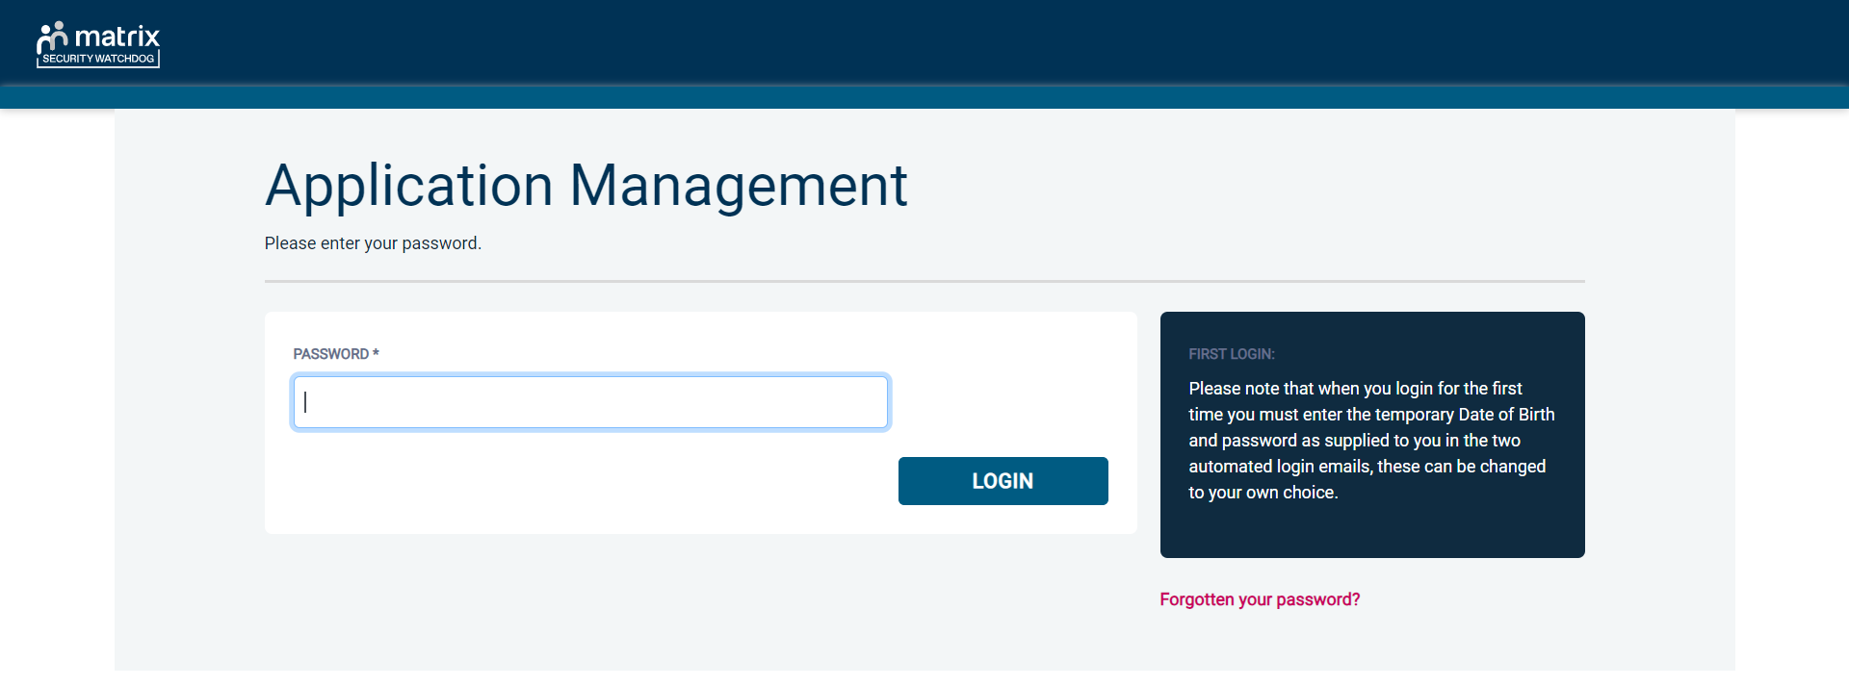
Screen Shot 2

- Please note, after initial login you will be required to set your own password and enter your own date of birth for future login purposes.
- Please re-enter into the ‘Current Password’ field the temporary password you received in your initial e-mail and then create your own unique password (see screen shot 3 below).
- The password you create must be between 8 & 30 characters containing at least one upper case letter, one lower case letter, one special character and at least one number.
- Please then enter a date of birth of your choice for future login purposes.
- Please then click ‘Update’.

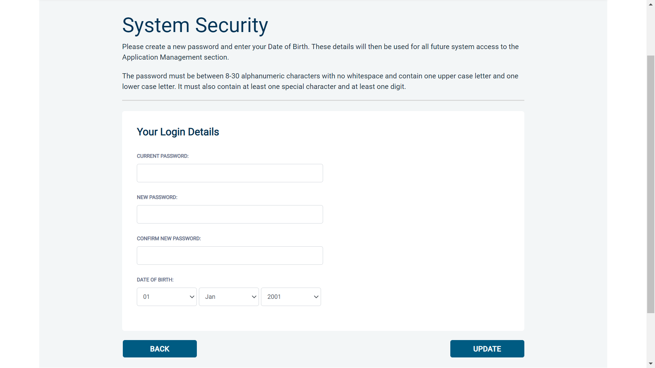
Screen Shot 3

- If you have successfully created your own password, you will now be able to enter the system by clicking the ‘Click here to enter System’ icon in the green box (please note you do not need to re-enter your password details once the green box has appeared).


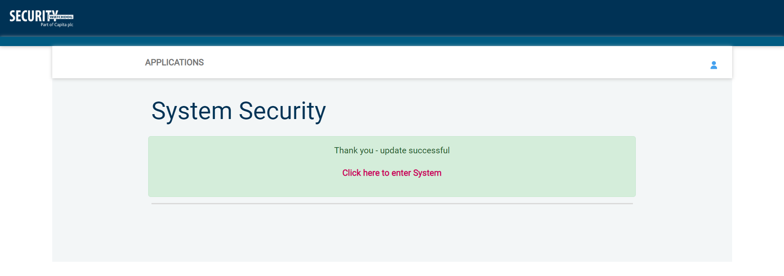
Screen Shot 4

- This will now take you to the main eBulkPlus Home Page called the ‘Dashboard’ (see screen shot 5 below).

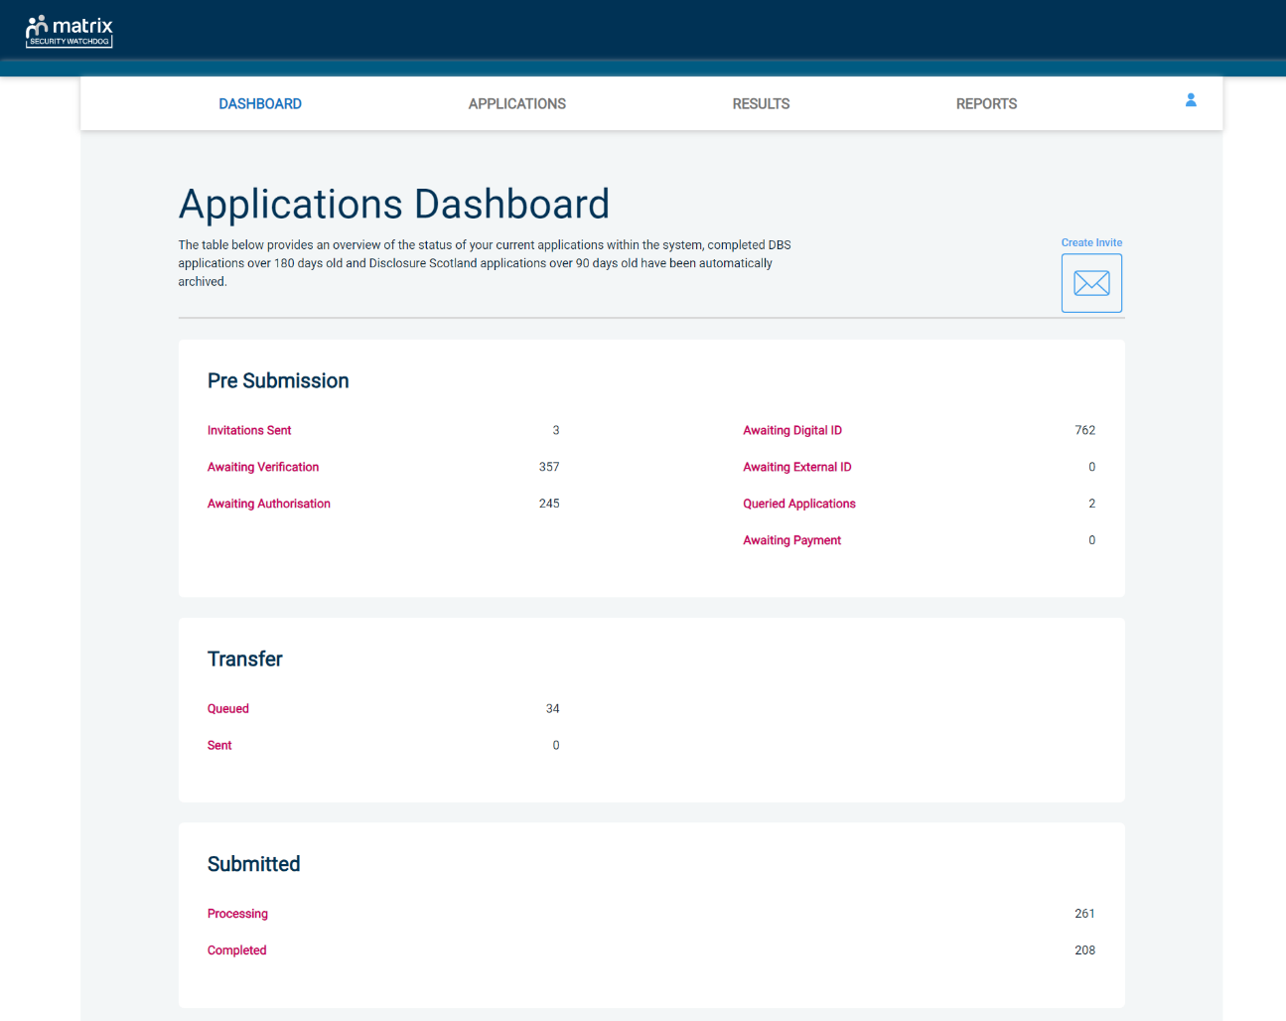
Screen Shot 5

Inviting an applicant to submit their application

You can generate an email invite to an applicant(s) inviting them to submit their application for any combination of the following checks – DBS/Disclosure Scotland check (with or without digital ID check) and digital Right to Work check, all from within the eBulk dashboard. This can be done by clicking the ‘Create Invite’ button at the top of the dashboard.

You will be taken to the invitation page where you can generate your invite (screenshot 6 below).

- You will need to select the ‘Organisation’ that you wish the applicant to create their application under, you will be able to select any organisations that you are linked to. You will be able to select the types/levels of check that you require the applicant to submit from the ‘Checks Required’ tick list below.
- You are then required to enter the applicant’s forename, surname and email address into the boxes provided. If you wish to invite more than one applicant to create this specific level of check for this specific organisation you can click the ‘Add Candidate’ button as many times as required to invite multiple applicants.

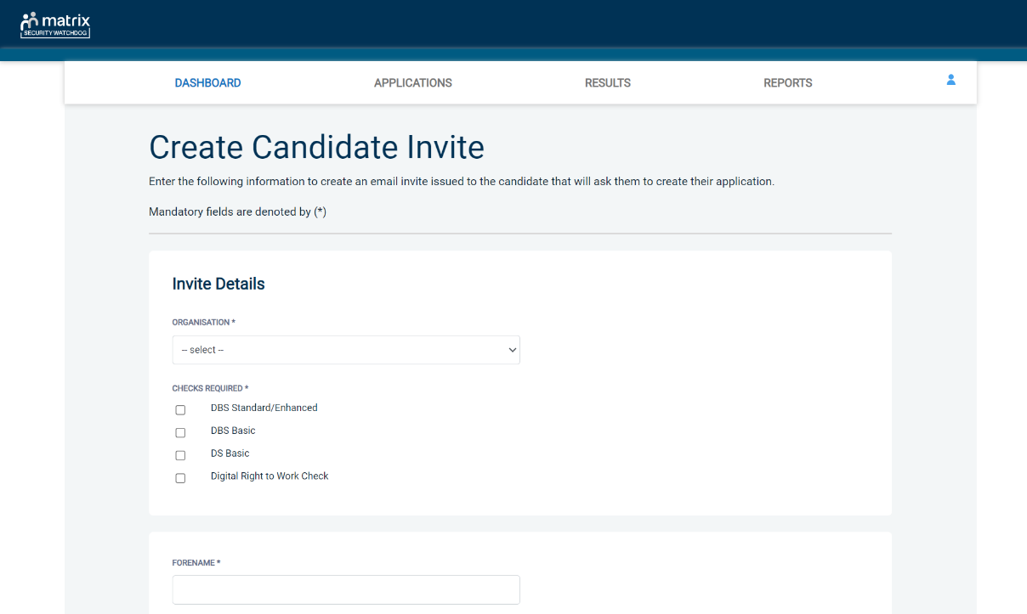
Screen Shot 6

- If you need to invite a large list of individuals, you can use the ‘Bulk Upload’ feature instead allowing you to upload a spreadsheet of applicants to be invited (screenshot 7 below). If you wish to use this feature, please leave the forename, surname, and email address fields blank and instead upload a pre-created spreadsheet. A blank template is provided in the eBulk footer if required. The spreadsheet must contain 3 columns only (Forename, Surname, Email address), any invalid data contained in the spreadsheet when uploaded will fail validation and be highlighted to you at the top of the screen.

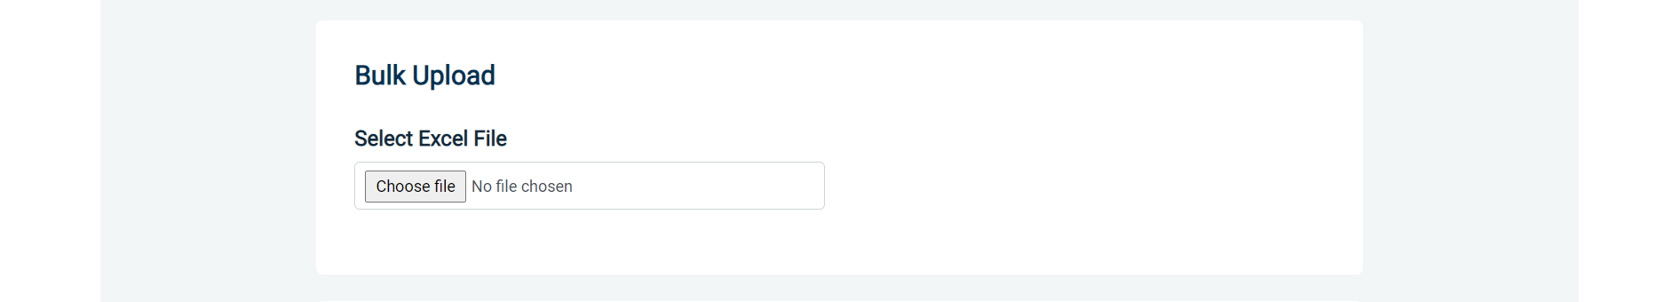
Screen Shot 7

- Next, you are required to select a template from the ‘Email Template’ drop-down field (screenshot 8 below). You will have different template choices available to you based on the checks requested as part of the invite. Selecting one of these will populate the content of the invite email on-screen for you to review and amend if required. The pre-populated wording of these templates will either be the default wording coded into our system or a bespoke template for your organisation.
- Finally, click ‘Send’ to generate the invite to issue the invite to the applicant(s) entered.

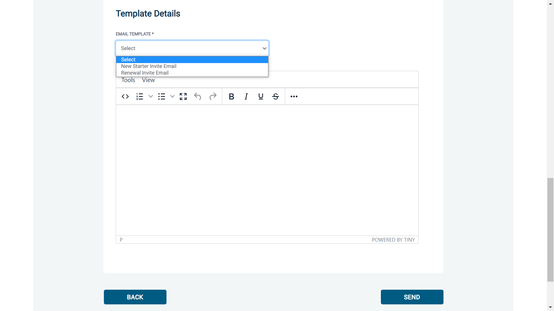
Screen Shot 8

How to track/chase invitations

Step 1 - Once invitations have been generated and sent, they are stored in the system until the applicant creates their application from the invite they have received. On the Dashboard page (see screen shot 5 above), in the top box entitled Pre-Submission, click on ‘Invitations Sent’.

You will be able to see the invitations that have been sent, waiting for the applicant to create their application. When an applicant has created their DBS/DS application from the invite they have received, it will move from this dashboard folder and into the ‘Awaiting Verification’ folder. A Right to Work application form will move from into the ‘Awaiting Digital ID’ folder.

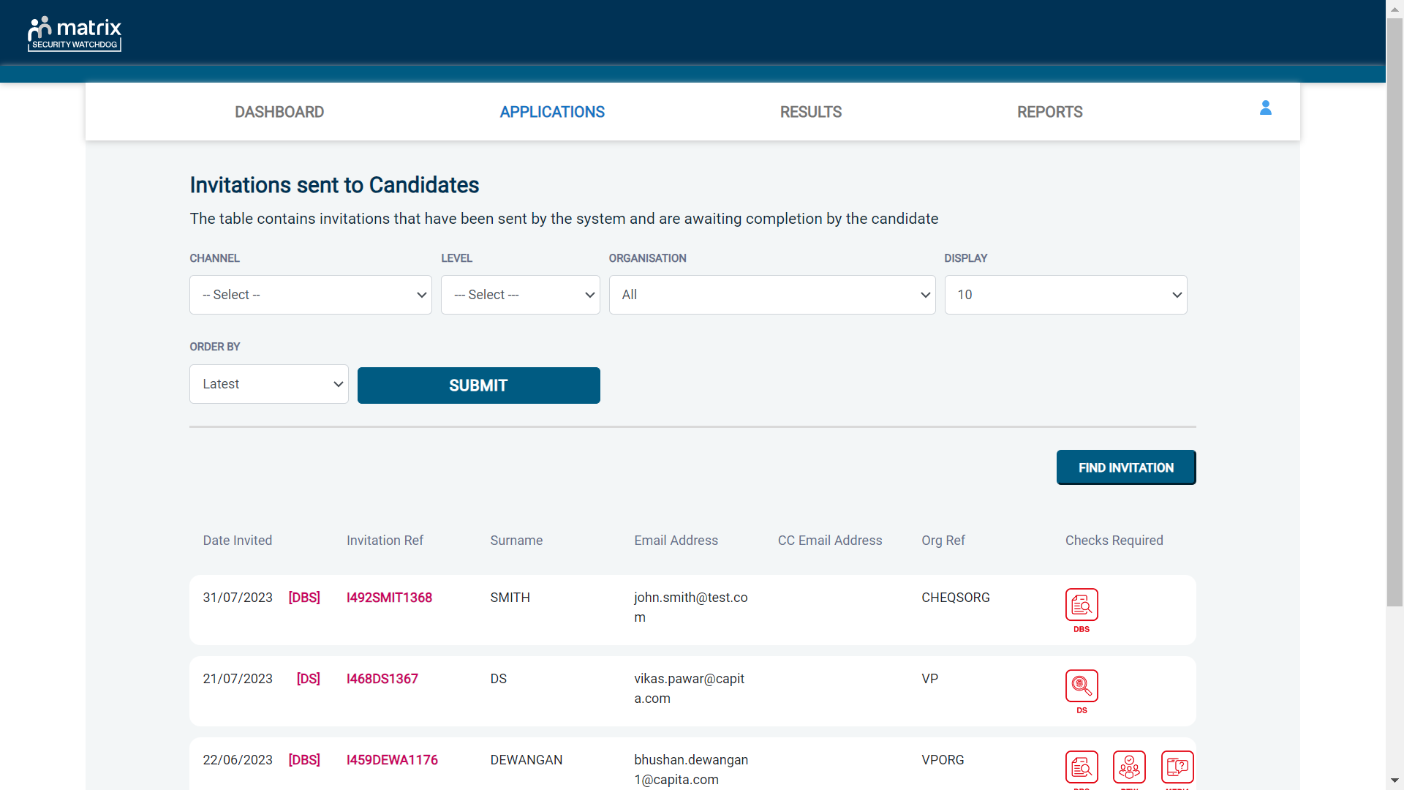
Screen Shot 9

Step 2 - Opening an invite: Click on an applicant’s reference number to open their invitation (see screen shot 9 above)

Step 3 – Overview, you will now see two tabs of the invitation (see screen shots 10 & 11 below)

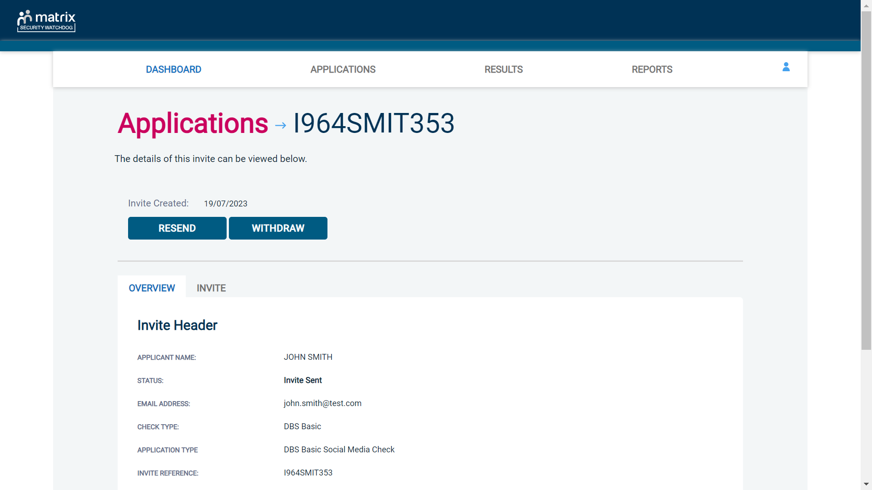
Screen Shot 10
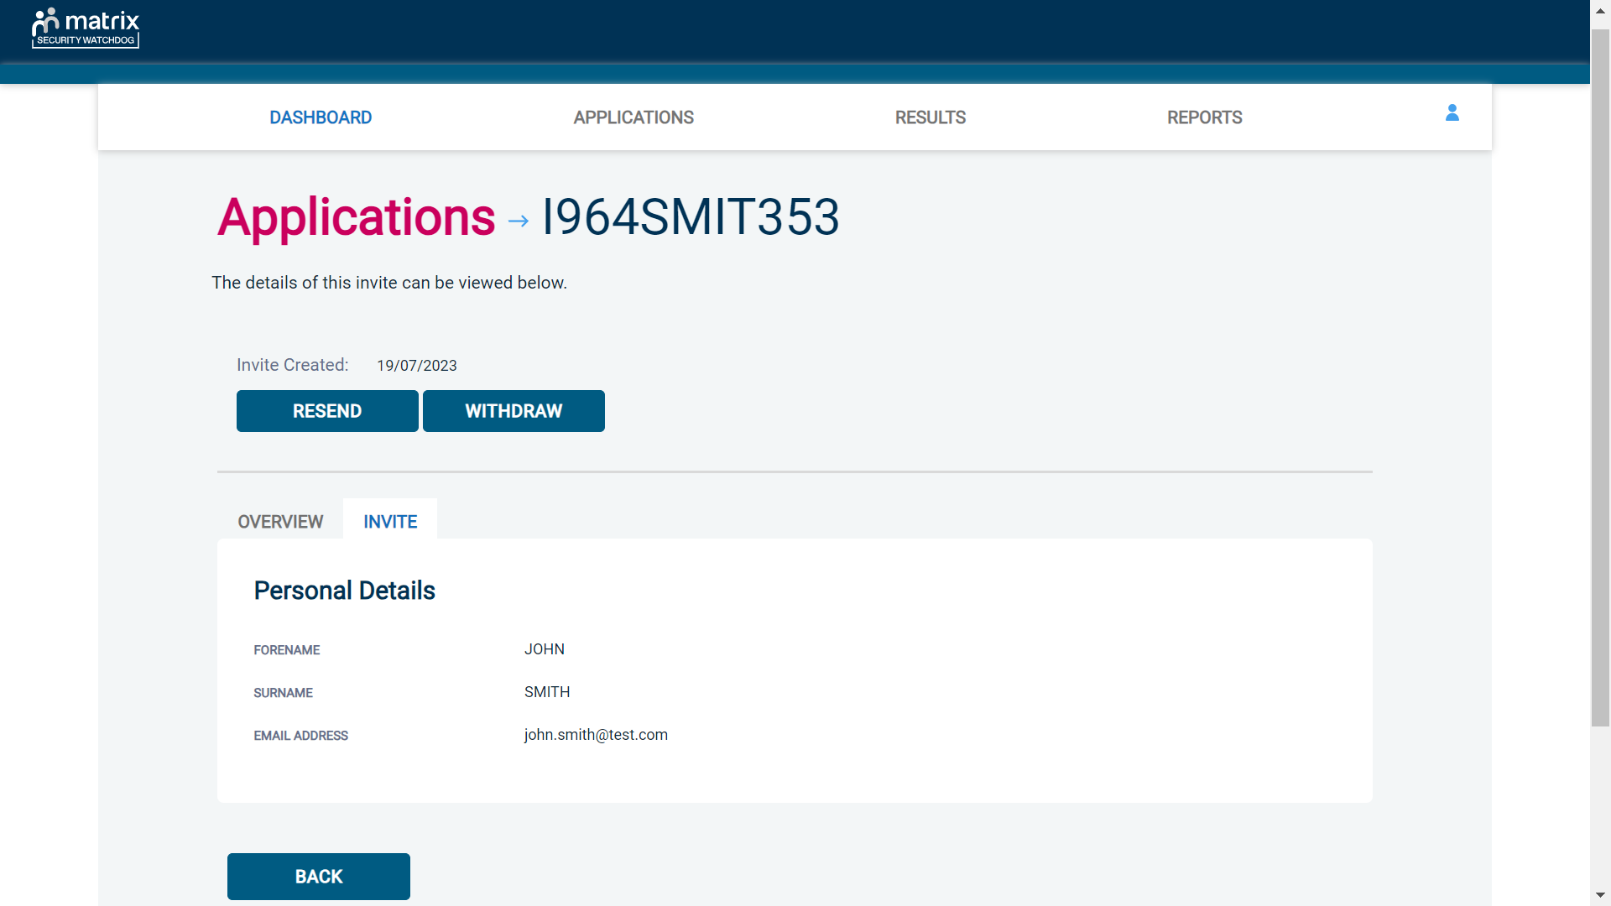
Screen Shot 11

Step 4 – Invitation, to view the details entered for the invitation click the ‘Invite’ tab. If these details are incorrect, these can be updated by a user with the appropriate access (see screen shot 11).

Step 5 – Chasing an invitation

- If you wish to resend the invitation, please click the ‘Resend’ button at the top of the page. This will resend the original invitation email to the email address detailed on the ‘Invite’ tab.
- Invitations will be automatically chased by the system at a default chase pattern of 3 times every 3 days unless a different chase pattern has been configured for your organisation. After the final chase, the applicant will then have a further 30 days to create their application until the invitation is automatically withdrawn by the system.
- If the invitation is no longer required, it can be withdrawn at any time using the ‘Withdraw’ button at the top of the page. This will remove the invite from the ‘Invitations Sent’ folder.

How to verify ID & Complete Section Y

Step 1 – On the Dashboard page (see screen shot 5 above), in the top box entitled Pre-Submission, click on ‘Awaiting Verification’. Please note that you will be able to see the total number of application forms you have awaiting ID verification and Section Y to be completed.

The DBS applications in this folder can be filtered using the ‘ID Check’ and ‘Section Y’ drop-down menus from the toolbar if the ‘Channel’ has been set to ‘DBS’. These can be used to only see applications awaiting just the ID Check, just Section Y, or both. It can also be used to filter out applications that have had both the ID Check and Section Y completed, but that are just awaiting approval (see screen shot 6 below)

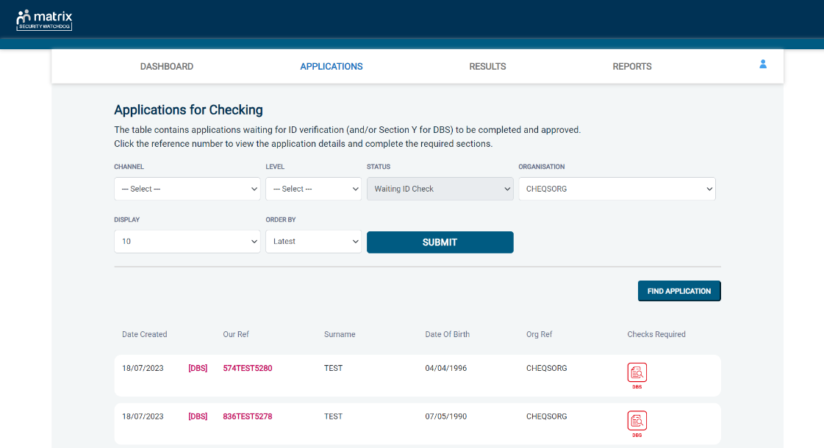
Screen Shot 12

Step 2 - Opening an application form:

Click on an applicant’s reference number to open up their application form (see screen shot 13 below)

Screen Shot 13

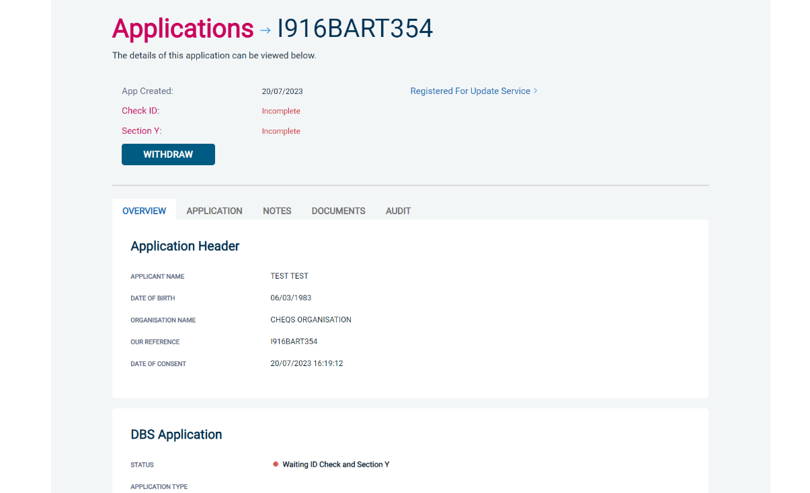
Screen Shot 14

Step 3 – You will now see an overview of the applicant’s completed form with 4 other available tabs, Application, Notes, Documents and Audit (see screen shot 14).

- Notes tab – this provides the facility to add any notes relating to an application for other Primary Applicant Managers to see. To add a note, click the ‘Notes’ tab then click the ‘Add Note’ button. After entering the note, select ‘Save’.
- Documents tab – the reports returned as a result of any digital ID or digital RtW Check will be available to download from this tab.
- Audit tab – this provides a real-time audit trail of any activity relating to an application. This will show the date and time when a user views or edits an application as well as when the ID Check/Section Y was completed.

Step 4 – Application, to view the application details entered by the applicant, click on the ‘Application’ tab. Here you can see the entire application submitted by the applicant, this can be used to ensure the correct job role has been entered and to verify any ID given by the applicant in a previous surname or previous address (see screen shots 15 & 16).

If any of the information stated on the application is incorrect this can be amended. To edit any part of the application, click ‘Edit’ against that section of the application. Once you have amended the information on the application, click the ‘Next’ button at the bottom of the page to go back to the overview screen. A Primary Applicant Manager can amend any part of the application up until it has been countersigned by us; once the application has been countersigned it can no longer be edited.

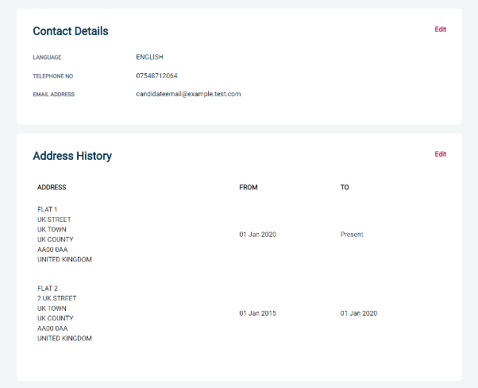
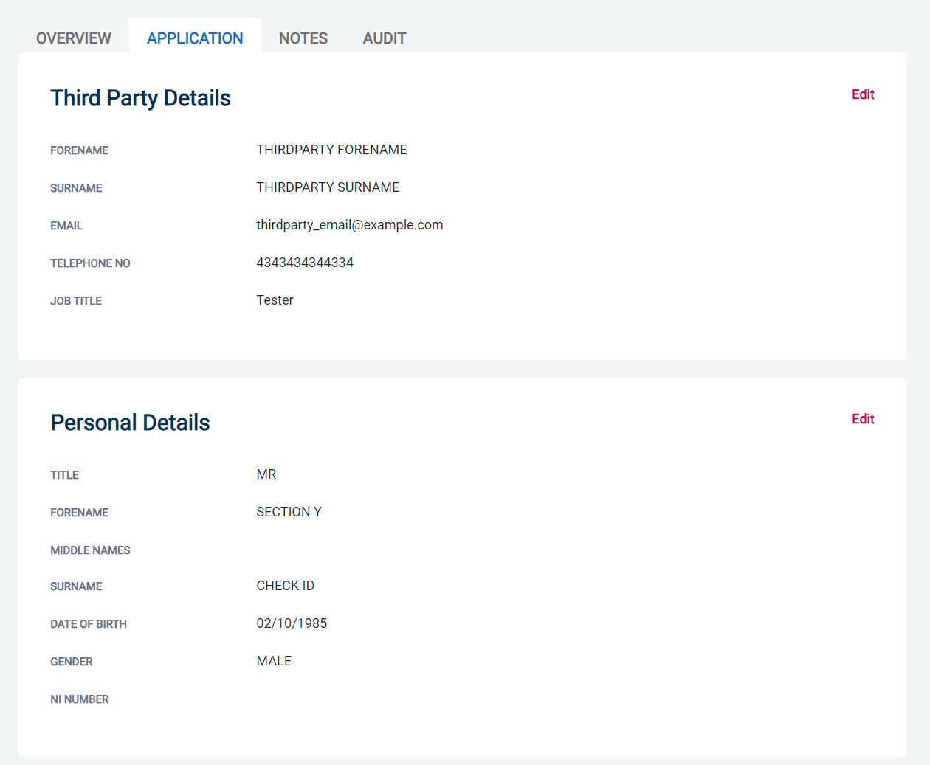
Screen Shot 16
Screen Shot 15
Step 5 - Verifying ID

- You will notice at the top of the screen a box which highlights if the ID has been verified or not (see screen shot 14 above), with a section completion date. It will say in red ‘Incomplete’ if the section has not been completed for either ID verification or Section Y. If there is a date entered it means that this action has been completed and will show the date that it was carried out on. If a digital ID check has already been requested but hasn’t yet completed, it will state ‘Pending Digital ID Result’

- To complete the ID verification section, click on ‘Complete ID Check’, access to this section is located in two places – at the top of the screen or on the overview of the actual form itself. You will now be on the ID screen (see screen shot 17 below).

You will have three options for how you wish to perform the identity check. This can be carried out by using a certified identity service provider (IDSP) or by manually witnessing original documents provided to you.

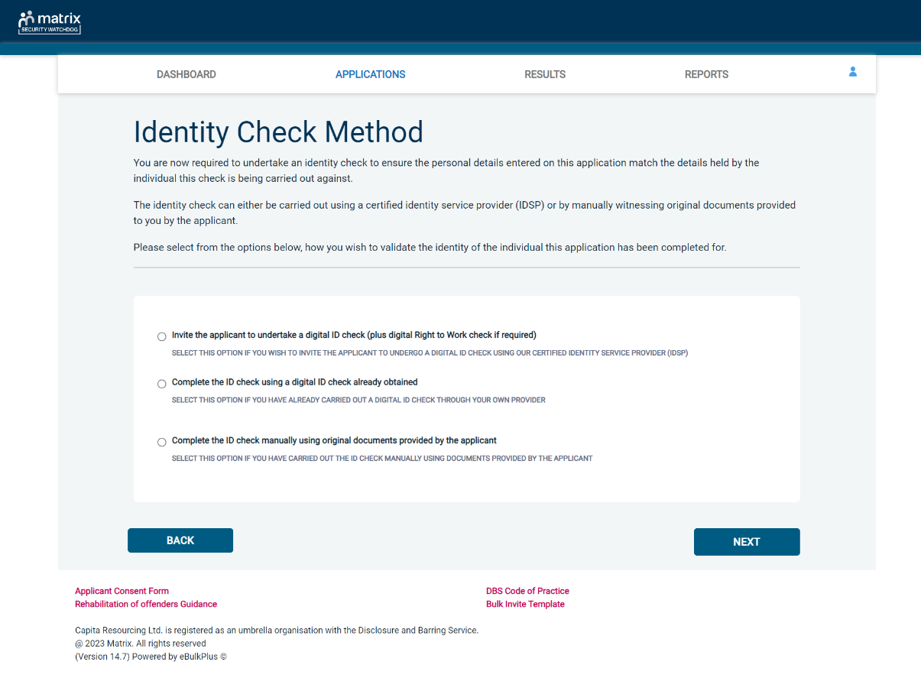
Screen Shot 17

Verifying identity using the eBulk digital ID integration

This facility allows for the identity verification to be performed digitally and remotely without the need for the applicant to present original documents to you to be verified. It also allows you to request a digital Right to Work check at the same time as performing the identity verification digitally.

If you didn’t request a digital ID check as part of the invite created and you wish to carry out the identity check using our certified identity service provider, please select ‘Invite the applicant to undertake a digital ID check (plus digital Right to Work check if required)’ (see screen shot 17 above.)

You will now be taken to the digital invite page which will automatically populate the name and email address of the applicant where present (see screen shot 18 below.) To invite the applicant to undertake just a digital ID check, please select ‘Digital ID Check Only’ from the ‘Digital ID Check Type’ drop-down list and ensure their name and email address are populated along with selecting the email template to issue them. This will generate an email to the applicant allowing them to carry out their digital ID check via our certified IDSP.
To invite the applicant to undertake a digital ID check and a digital Right to Work Check, please select ‘Right to Work + Digital ID Check’ from the ‘Digital ID Check Type’ drop-down list and ensure their name and email address are populated along with selecting the email template to issue them. This will generate an email to the applicant allowing them to carry out their digital ID check and digital Right to Work check at the same time via our certified IDSP.


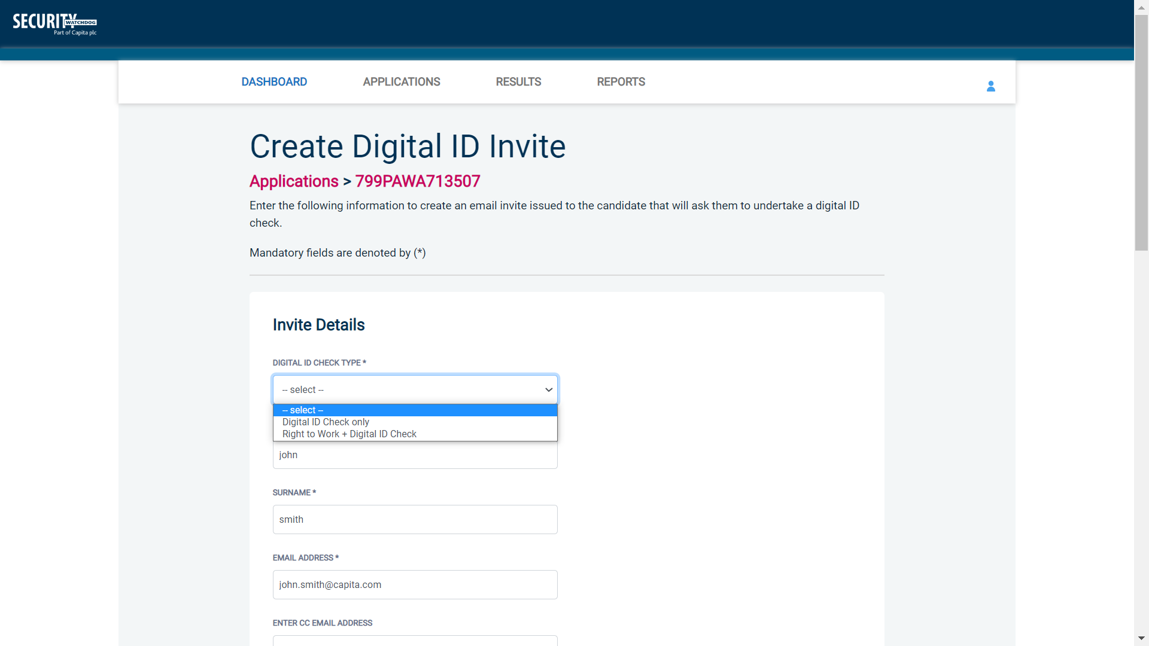
Screen Shot 18

Applicants that have been invited to do a digital ID check can be found in the ‘Awaiting Digital ID’ queue on the main dashboard (see screen shot 5 above.)

Once the digital ID check has been carried out, the ID section of the application will be updated with either a pass or fail result and a PDF report of the digital ID check can be downloaded by clicking the ‘Download Digital ID Report’ button (see screen shots 19-22 below.)

If the result of the digital ID check is ‘FAIL’, you must read the digital ID report to understand why and verify their identity manually depending on the reason the digital ID check failed. To do this, click the ‘RESET ID CHECK’ button at the bottom of the ID screen to restart the identity process, this time selecting an alternative method.

If the result of the digital ID check is ‘PASS’, the ID section will be auto completed upon receipt of the digital ID check result and there will be nothing further to do in relating to the identity verification part of the process.

If a digital Right to Work check was also requested, a ‘RTW Check’ element will be added to the header of the application and will be updated with either a pass, fail or see report result. A PDF report of the digital Right to Work check can be downloaded by clicking the ‘Download Digital ID Report’ button from either the ID screen or the RTW screen.
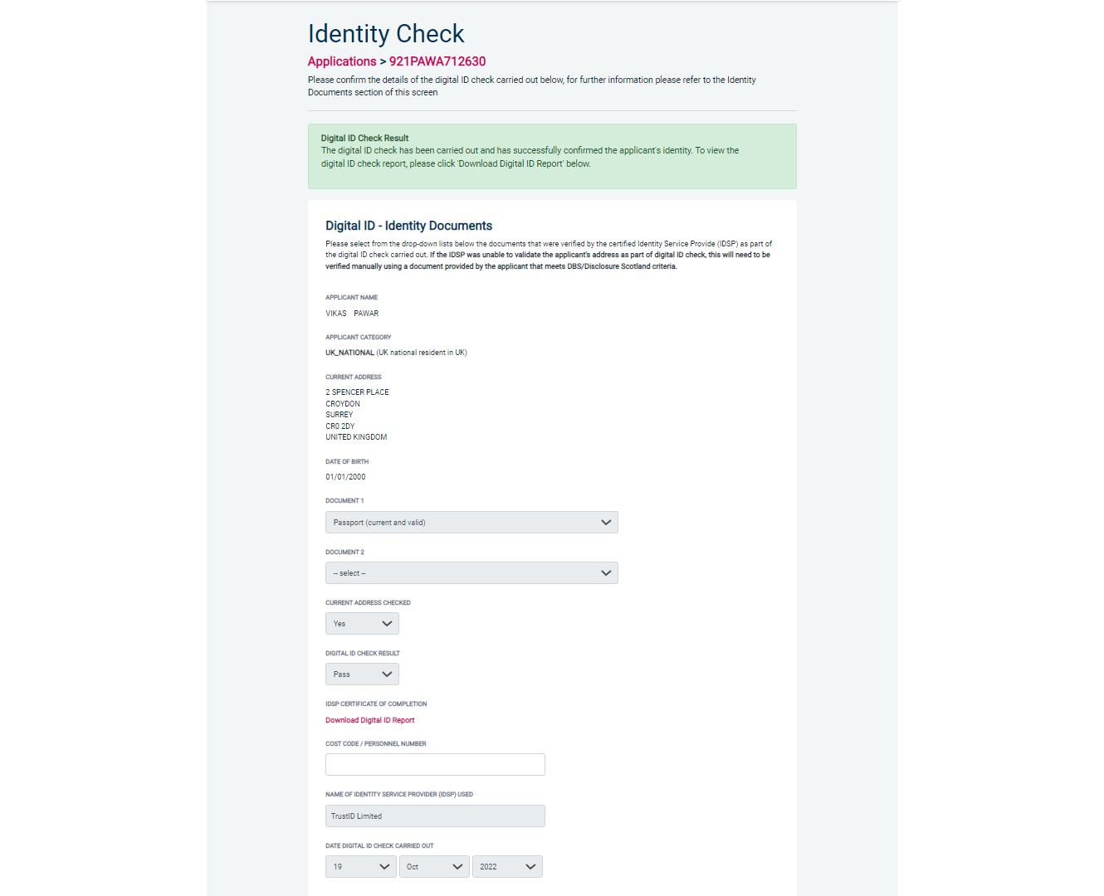
Screen Shot 19

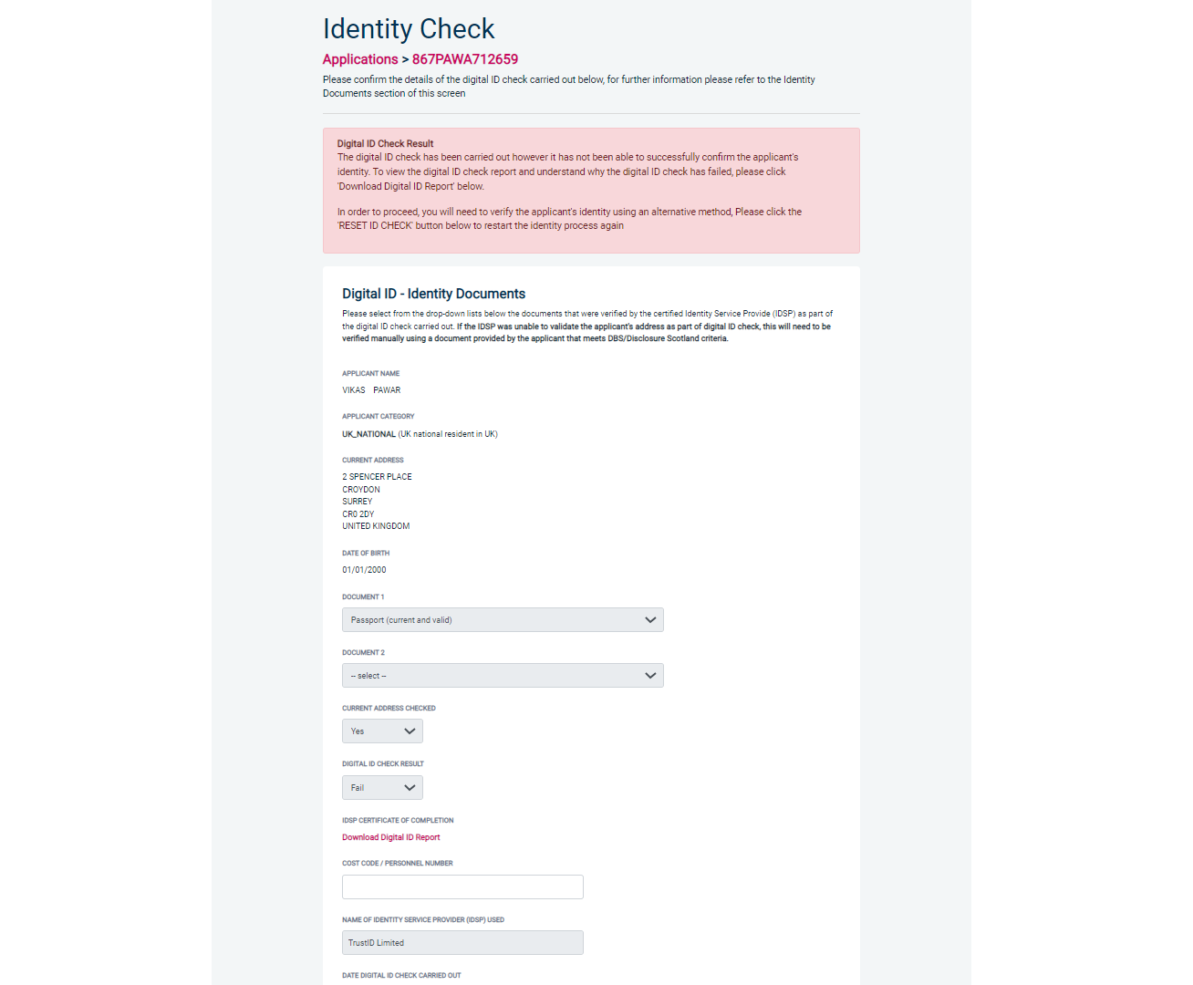
Screen Shot 20
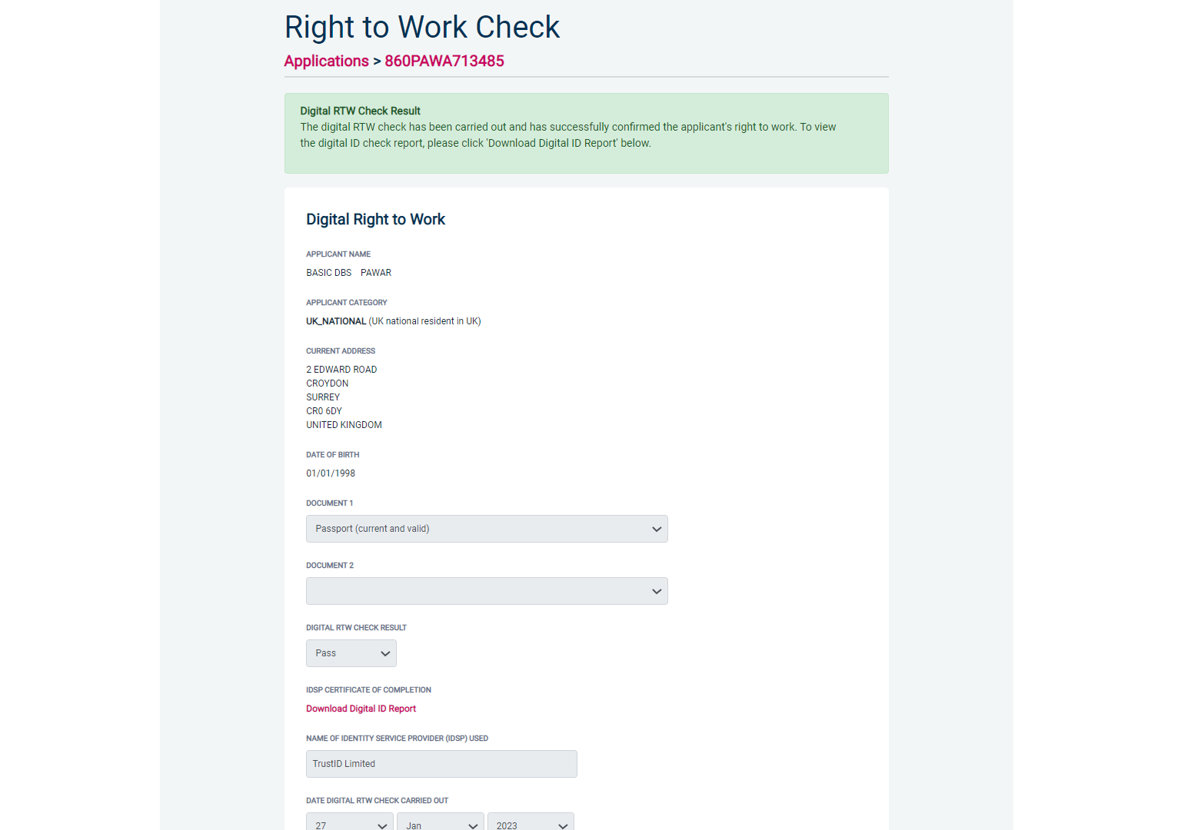
Screen Shot 21

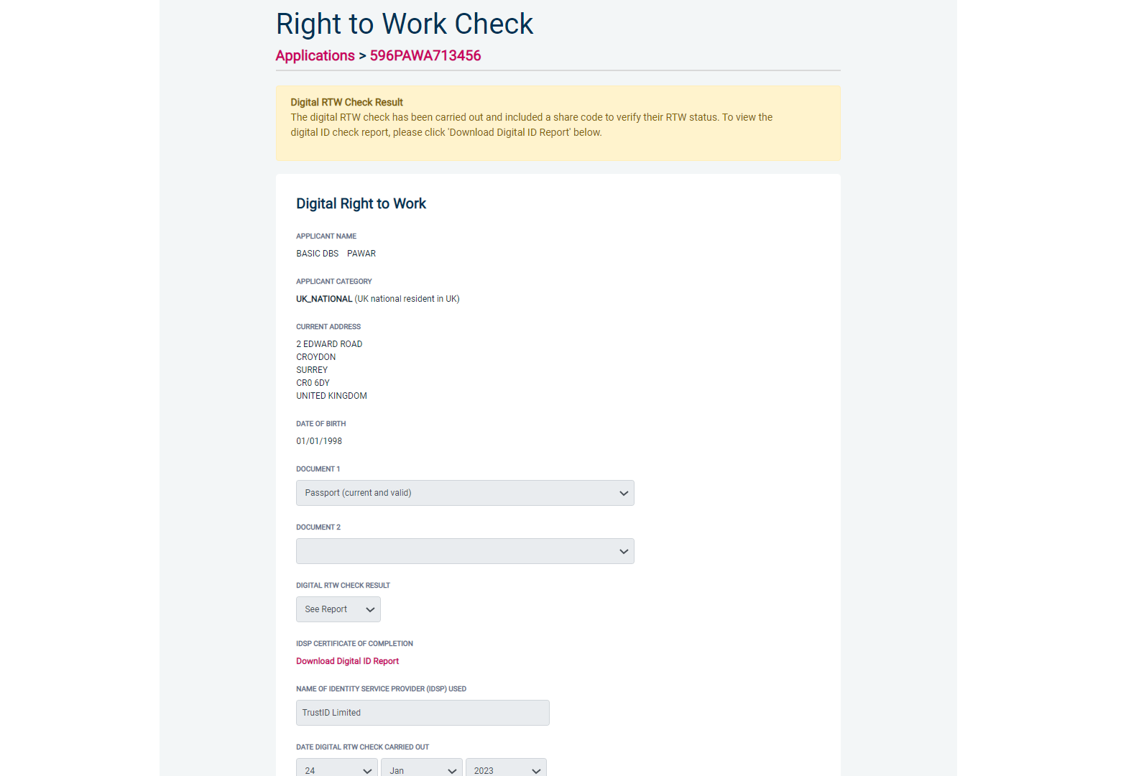
Screen Shot 22

Verifying identity using a digital ID check already obtained

This facility allows you to verify the identity using a digital ID check already obtained via your own IDSP outside of our platform. If you wish to verify the identity using this method, please select ‘Complete the ID check using a digital ID check already obtained’ (see screen shot 17 above and screen shot 23 below.)

- Please select the ID documents verified by the IDSP as part of the digital ID check undertaken.
- Ensure that you confirm from the drop-down boxes that they have verified the applicant’s address and also that they have verified a document containing their date of birth.
- Please upload a copy of the digital ID report obtained from your IDSP by clicking ‘Choose File’
- If a Cost Code or Personnel Number is required to be assigned to the specific application, this can be entered in the Cost Code / Personnel Number field.
- Now click ‘Save’ and then click the ‘Return to Application’ icon in the green box located at the top of the screen. Now you are ready to complete Section Y of the form (this is the equivalent to Section X on the new lilac paper DBS application forms).
- Once the ID Check has been saved, if you realise that it has been completed incorrectly or through the wrong route, you can reset the ID Check section and complete it again if required. Please note, you will only be able to do this if you have been assigned the appropriate user privilege to do so. To do this, go back into the ID Check screen and click the ‘Reset ID Check’ button found at the bottom of the screen.

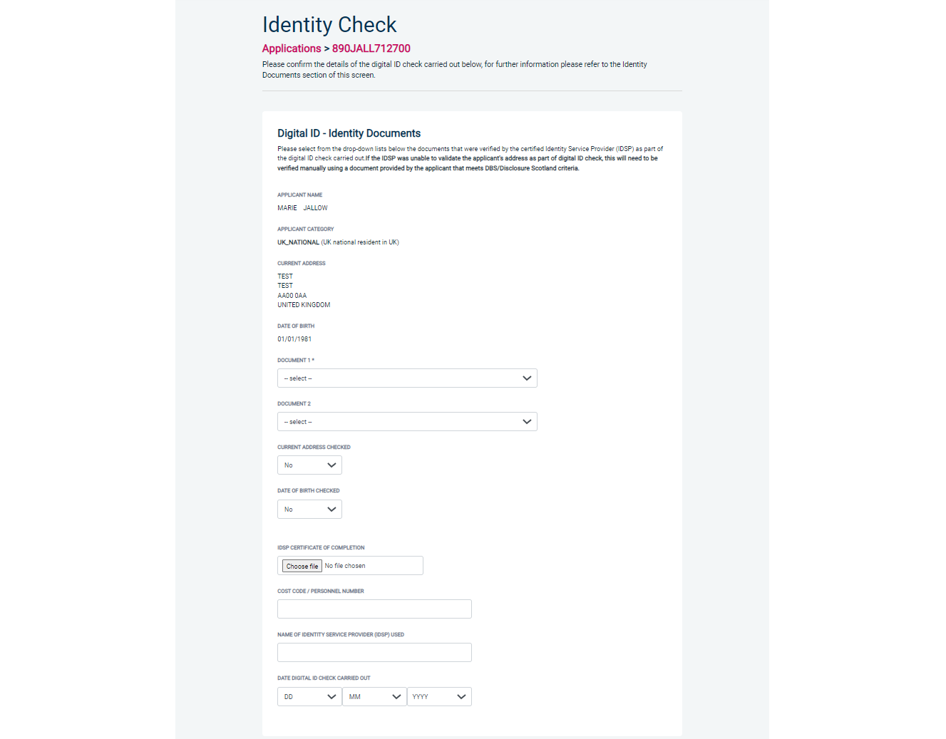
Screen Shot 23

Verifying identity using original documents provided to you by the applicant

If you do not wish to verify identity using a digital ID check, please select ‘Complete the ID check manually using original documents provided by the applicant’ (see screen shot 17 above and screen shot 24 below.)

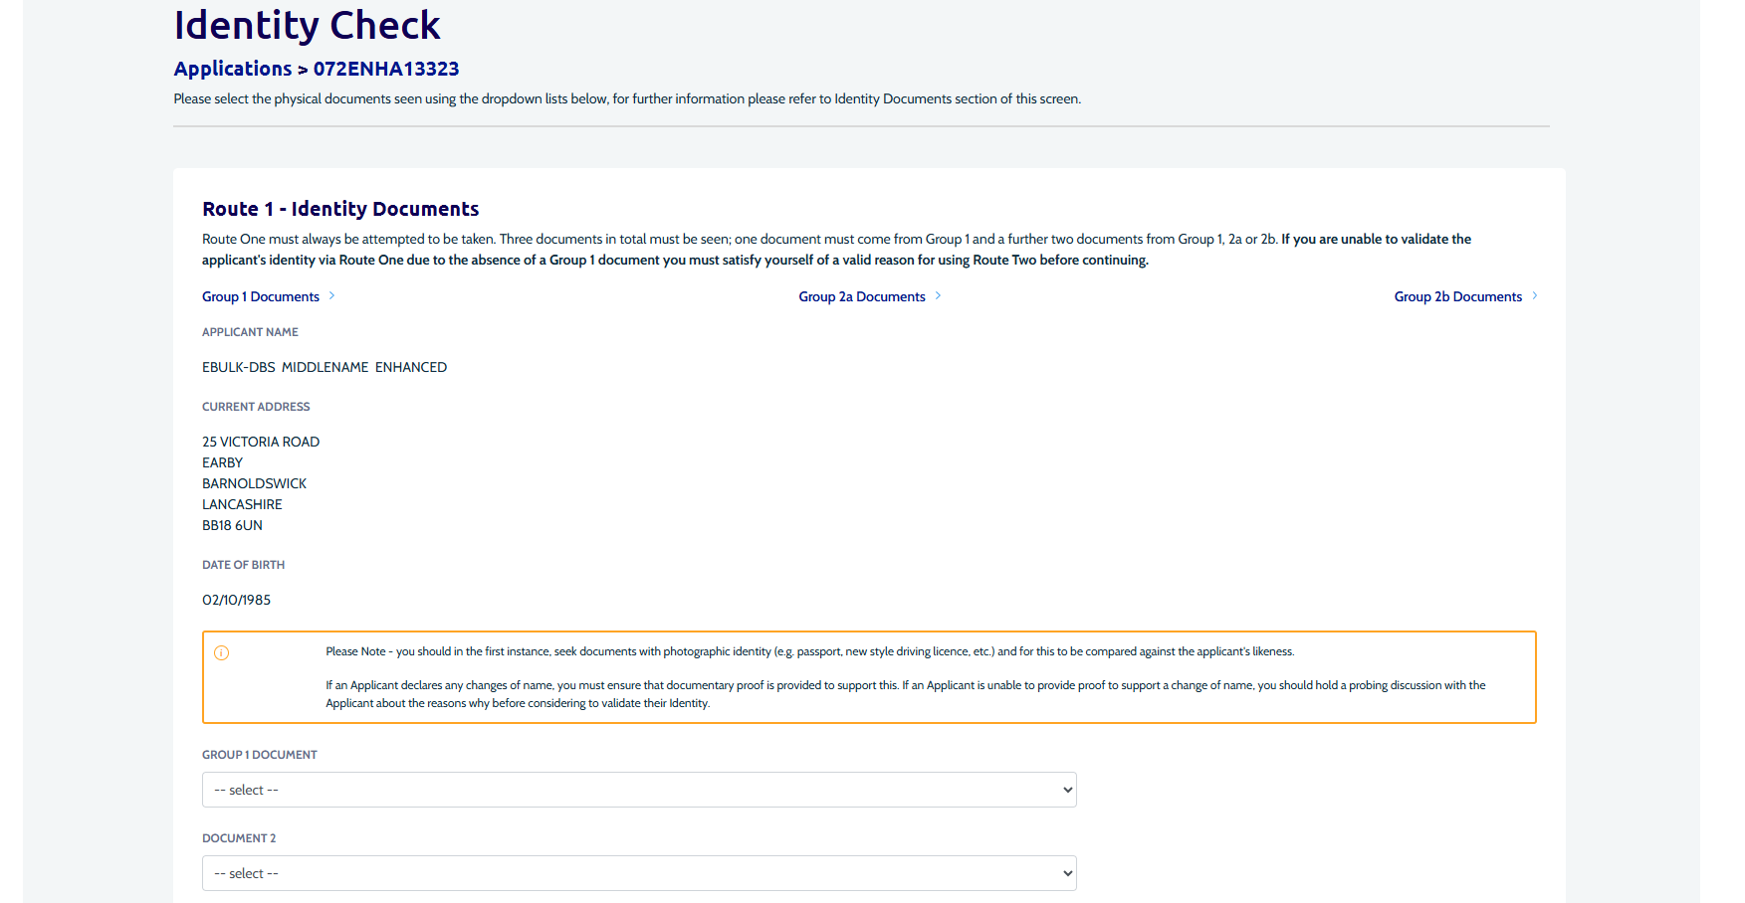
Screen Shot 24

eBulkPlus will automatically commence with Route 1, assuming that the applicant has the appropriate documents required for Route 1. If an applicant does not hold sufficient ID to be able to go through Route 1, you will be required to click the ‘Next Route’ button at the bottom of the screen.

- Please select the ID the applicant has provided for you from the drop-down boxes. Guidance notes can be found at the top of the screen and are in accordance with the DBS Code of Practice. Please ensure at all times that you follow the ID checking rules e.g. do not accept a utility bill if it is more than 3 months old or do not accept an out-of-date passport.
- Ensure you confirm that you have verified a document showing the applicant’s date of birth.
- If a Cost Code or Personnel Number is required to be assigned to the specific application, this can be entered in the Cost Code / Personnel Number field.
- Now click ‘Save’ and then click the ‘Return to Application’ icon in the green box located at the top of the screen. Now you are ready to complete Section Y of the form (this is the equivalent to Section X on the new lilac paper DBS application forms).
- Once the ID Check has been saved, if you realise that it has been completed incorrectly or through the wrong route, you can reset the ID Check section and complete it again if required. Please note, you will only be able to do this if you have been assigned the appropriate user privilege to do so. To do this, go back into the ID Check screen and click the ‘Reset ID Check’ button found at the bottom of the screen.

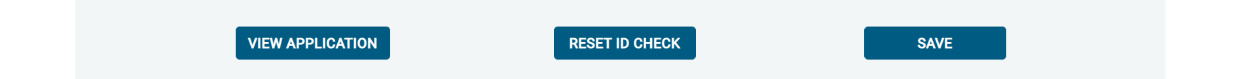

Please note, that if an applicant cannot verify their identity via Routes 1, 2 or 3 they will not be able to process their application through eBulk and will need to complete a paper application stating ‘NO’ in section W59. Fingerprints will need to be taken and consent will be required by the applicant.

*A full list of DBS acceptable ID for each route can be found at the end of this guide*

What you must do as part of the ID Checking process

When verifying identity manually, the applicant must provide a range of ID documents as part of the DBS check application process. As an employer you must:
- Make sure that any details of current passport, driving licence and National Insurance Number are included on the paper or electronic application form.
- Follow the three route ID checking guidance set out below.
- Consider using digital ID verification if the applicant can present a passport or driving licence.
- Seek photographic identity documents (passport, driving licence, e-Visa or PASS card) in the first instance. This can be used to compare the applicant’s likeness. Check and validate the information provided on the application form by the applicant.
- Check that the application form is completed in full and the information it contains is accurate. For example, that all addresses lived at in the last 5 years and names known by have been declared and are accurate. Failure to do this can result in delays in processing and the withdrawal of applications.
- Make sure the applicant fills in the address part of the form correctly if they have an unusual address, for example if they live abroad, in student accommodation or a hostel.
- Use a document type only once in the document count. For example, don’t accept two bank statements as two of the required documents if they are from the same bank.
- Not alter or amend the application form without the knowledge or agreement of the applicant.
- Keep a record of the documents used to validate each identity for a minimum of 2 years. This is in line with compliance activity carried out by DBS. DBS will ask for records of documents checked as part of ID verification as part of this process. Documents can be recorded as copies of physical documents or PDF evidence of eVisa. If it is not possible to keep copies you should record:
  - document type,
  - country of issue
  - any expiry date,
  - any reference numbers, and
  - notes if there were any discrepancies discussed as part of the ID verification process.
- Verify their identity in accordance with the three ways in which ID documents can be viewed and validated. You must use option one unless it is impossible to have a face-to-face appointment with the applicant. If you are unable to use option one the reasons need to be recorded and option two can be considered. If option two is impossible the reasons must be recorded and option three can be used. The rationale behind the use of options two or three must be kept, along with a record of the documents used to validate the identity, for a minimum of 2 years.
  - Option One: The ID check should be done in person, allowing the ID checker to view the physical documents, or eVisa, or digital PASS card, in the presence of the individual. If you cannot use option 1, please consider using digital identity verification before considering option 2.
  - Option Two: The ID checker can conduct the ID check via video link – for example Google Meet or FaceTime. In these circumstances the ID checker must be in possession of the physical documents. These can be posted to the ID checker in advance of the virtual call. Any risks identified when using live video must be assessed and mitigated by you. You must not rely on the inspection of the documents via a live video link, or by checking a faxed or scanned copy of the document. If option two is used, you must keep a record of why option one was impossible, along with a record of the documents used to validate the identity, for a minimum of 2 years. The rationale must be specific to the individual ID verification, it is not acceptable to default to the use of options two or three.
  - Option Three: The ID check can be completed via video link – for example Google Meet or FaceTime – without the ID checker being in physical possession of the ID documents. The details of the documents, as set out above, must be recorded and stored at the time of the video link ID check. The documents must be presented to the ID checker on the first day of employment. The ID checker must record the date the ID check was completed in person and cross reference the details recorded from the video link ID check. If there are any discrepancies the DBS check may be invalid. If option three is used you must keep a record of why options one and option two were impossible, along with a record of the documents used to validate the identity, for a minimum of 2 years. The rationale must be specific to the individual ID verification, it is not acceptable to default to the use of options two or three.

Step 6 - Completing Section Y

- To complete Section Y click on ‘Complete Section Y’ (please refer back to screen shot 14). Access to this section is located in two places – to the top of the screen or on the overview of the actual form itself. You will now be on the ‘Section Y’ screen – (see screen shot 25).
- If required, guidance can be read by clicking on the ‘i’ tooltip icons if you require any clarification regarding the application type required or any other drop-down boxes within Section Y.

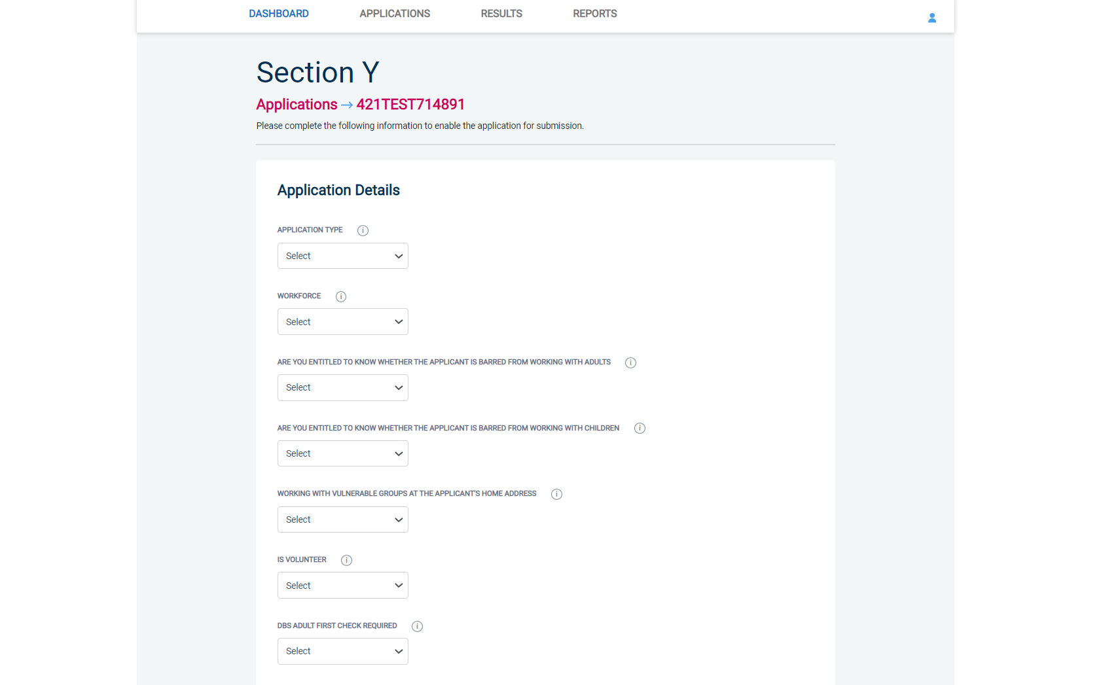
Screen Shot 25

- Please complete the application details by selecting Yes/No answers from each of the drop-down boxes. You can add additional information about an applicant and their job role if you wish in the box at the foot of this screen.

Workforce Categories

- Adult Workforce - use this for any position that involves working/volunteering with adults
- Child and Adult Workforce - use this for any position that involves working/volunteering with both children and adults
- Child Workforce - use this for any position that involves working/volunteering with children
- Other Workforce - use this for any position that does not involve working/volunteering with Children or Adults (e.g. security guard / electrician)

- Finally click ‘Save’ then scroll to the top of the screen to the green box and click ‘Approve’.

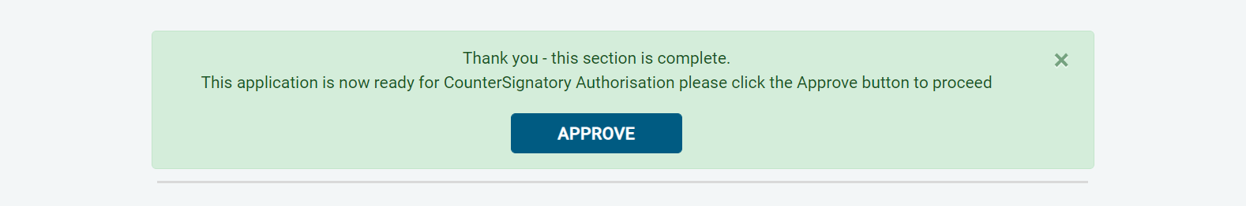

- Please ensure you click on ‘Approve’ – failure to do so will result in the form not being submitted for Countersignatory Authorisation.

- You have now completed this section; you will have no further action to take. The form will automatically transfer to your Registered Body to be countersigned, ready for onwards transmission to the DBS.

- *If an application does require further clarification from us prior to submission to the DBS, a query will be flagged on the application and we will contact you for clarification. During this time, a copy of the application record move into the ‘Queried Applications’ folder on the Dashboard (see Screen Shot 5) *

- Once a form has been countersigned by your Registered Body, the application will be moved to the ‘Transfer’ section. Applications at this stage are awaiting collection by the DBS. Once the DBS have collected them, they will move into the processing stage – please see below for further details.

NB. An application form can be withdrawn at any time up to and including Countersignatory stage. Once a form has been electronically transferred to the DBS, we cannot withdraw it without incurring the DBS charge. If you wish to withdraw an application at Countersignatory stage, please contact us immediately, to enable the process to be halted

DBS Processing

Step 1 – Tracking an application – see screen shot 26.

- On the Dashboard you will see towards the bottom of the screen, a box called ‘Submitted’.

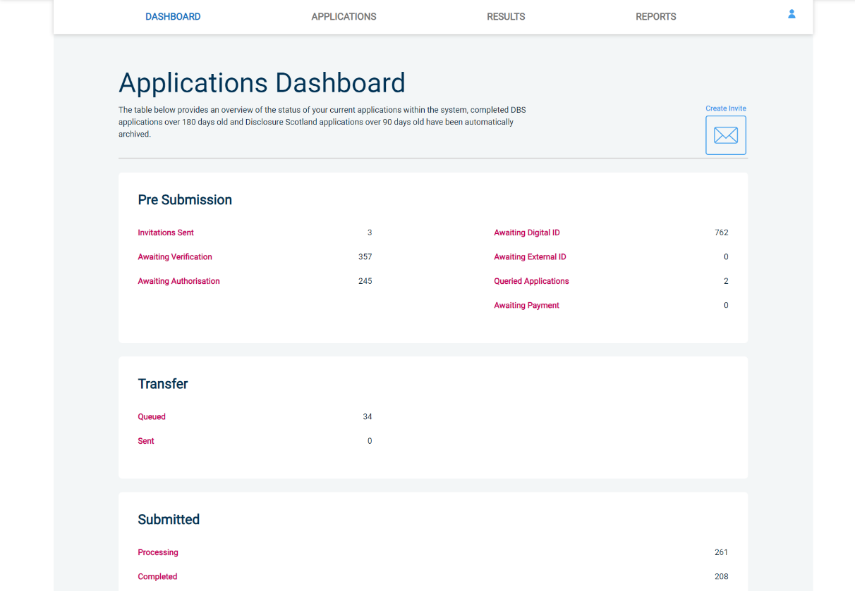
Screen Shot 26

- To track an application, click on ‘Processing’, this will take you to a screen which will show all the applications for your company that are currently being processed by the DBS. To track an individual’s DBS application, click on ‘Track’ next to their DBS reference number in the right-hand column (see screen shot 27). This will take you directly into the DBS’s tracking page for that applicant.

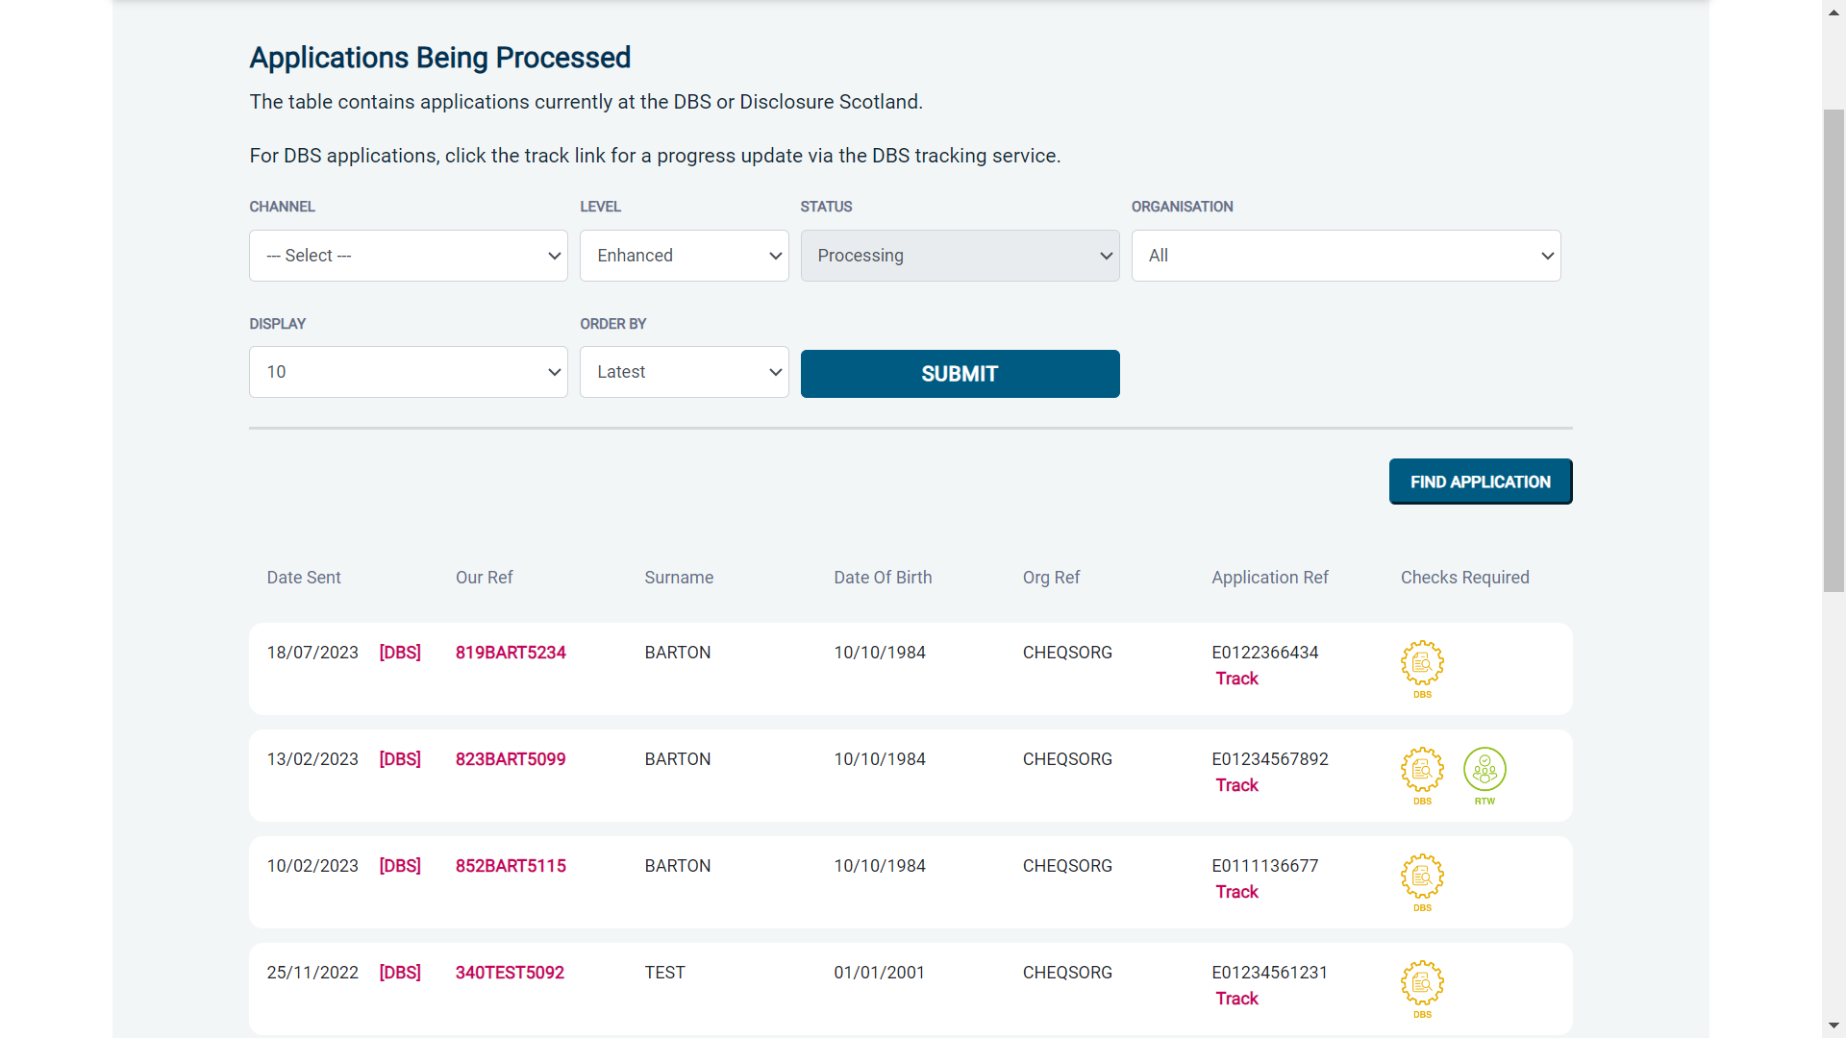
Screen Shot 27

Completed Results

DBS Results with content

Step 1 - Notification – see screen shot 28.

- The DBS will send notification online once an application has been completed. To view a result please return to the Dashboard and click on ‘Completed’ in the Submitted section.

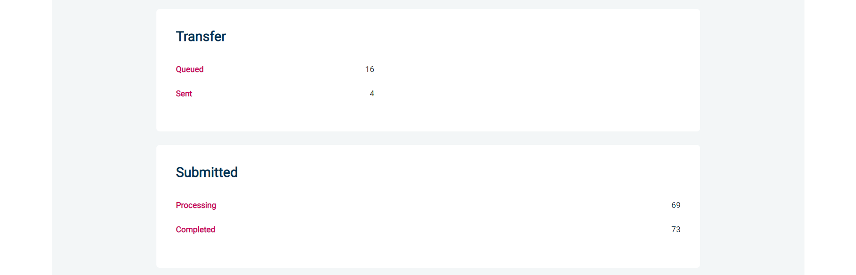
Screen Shot 28

Step 2 - Viewing a Certificate result with content – see screen shot 29.

- To view the information of a certificate e.g. certificate issue date, reference number and result status, click on the applicant’s reference number (see screen shot 29). This information will stay in the ‘Completed’ folder for 180 days from the issue date of the certificate.

- Certificate results with content will state “Please wait to view applicant certificate” in the Status column – This means the certificate contains information and you will have to view the applicant’s certificate to see this information.

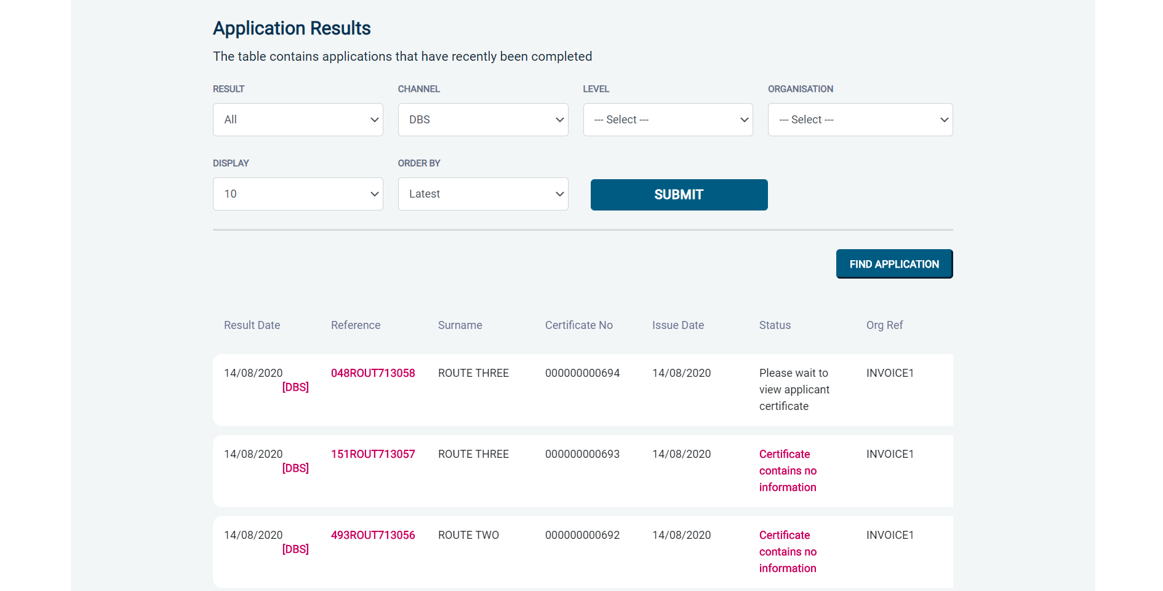

Screen Shot 29

Step 3 – Indicating sight of the applicant’s certificate – see screen shot 30.

To help an organisation keep track of which applicants have brought their certificate in and been viewed by the organisation, the system is able to record the date the applicant’s certificate has been seen by their organisation or whether sight is not required. As an Applicant Manager, you can add this date on to an application to indicate that their certificate has been sighted.

To add the date or to view whether a date has been added, click on the reference number of the application from the ‘Completed’ folder (see screen shot 29 above). Once in the application, the date can be added in the ‘Applicant’s Certificate’ section at the top of the screen (see screen shot 30 below).

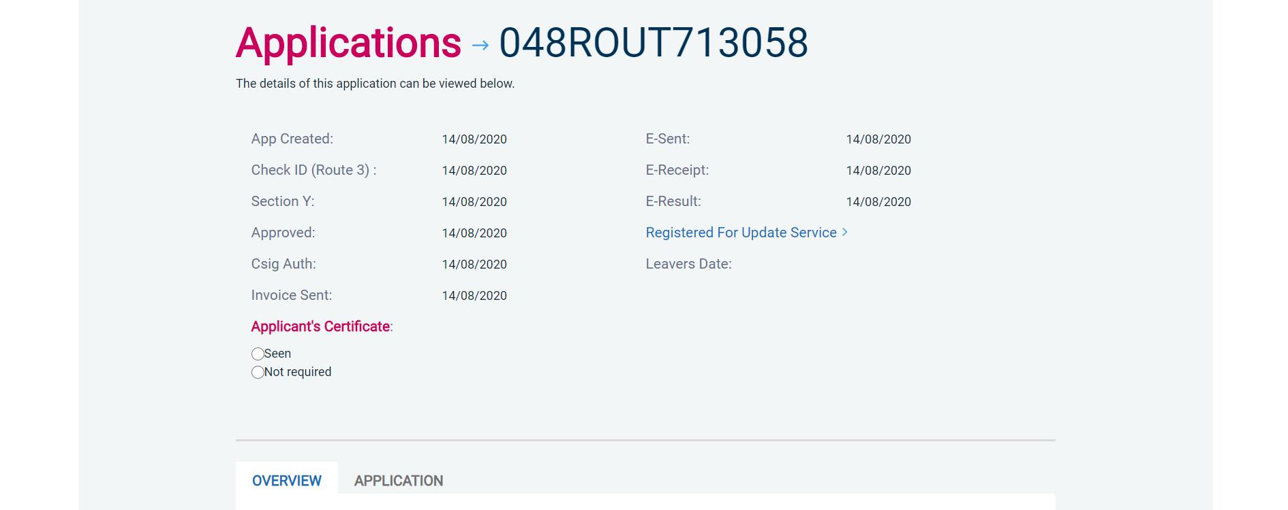
Screen Shot 30

Step 4 – Uploading a scanned copy of the applicant’s certificate – see screen shot 31.

As an Applicant Manager, you may have been granted permission to upload and/or view uploaded certificates attached to results with content. If you have been granted the upload privilege, you are able to upload a scanned copy of the applicant’s certificate to their application as long as you obtain their consent. If you wish to use this facility, you will need to mark the ‘Written consent has been obtained from the applicant?’ box, once ticked you will have facility to select the required file to upload.

Once a file has been uploaded, you will be able to view this as many times as you wish by clicking the ‘Download Certificate’ button until the application is archived after 180 days (see screen shot 31 below). If you have been granted the appropriate privilege, you may also have the ability to remove the uploaded certificate by clicking the ‘Remove Certificate’ button. Please note a sample ‘Applicant Consent Form’ can be downloaded from the footer of eBulkPlus to use to obtain applicant’s consent.

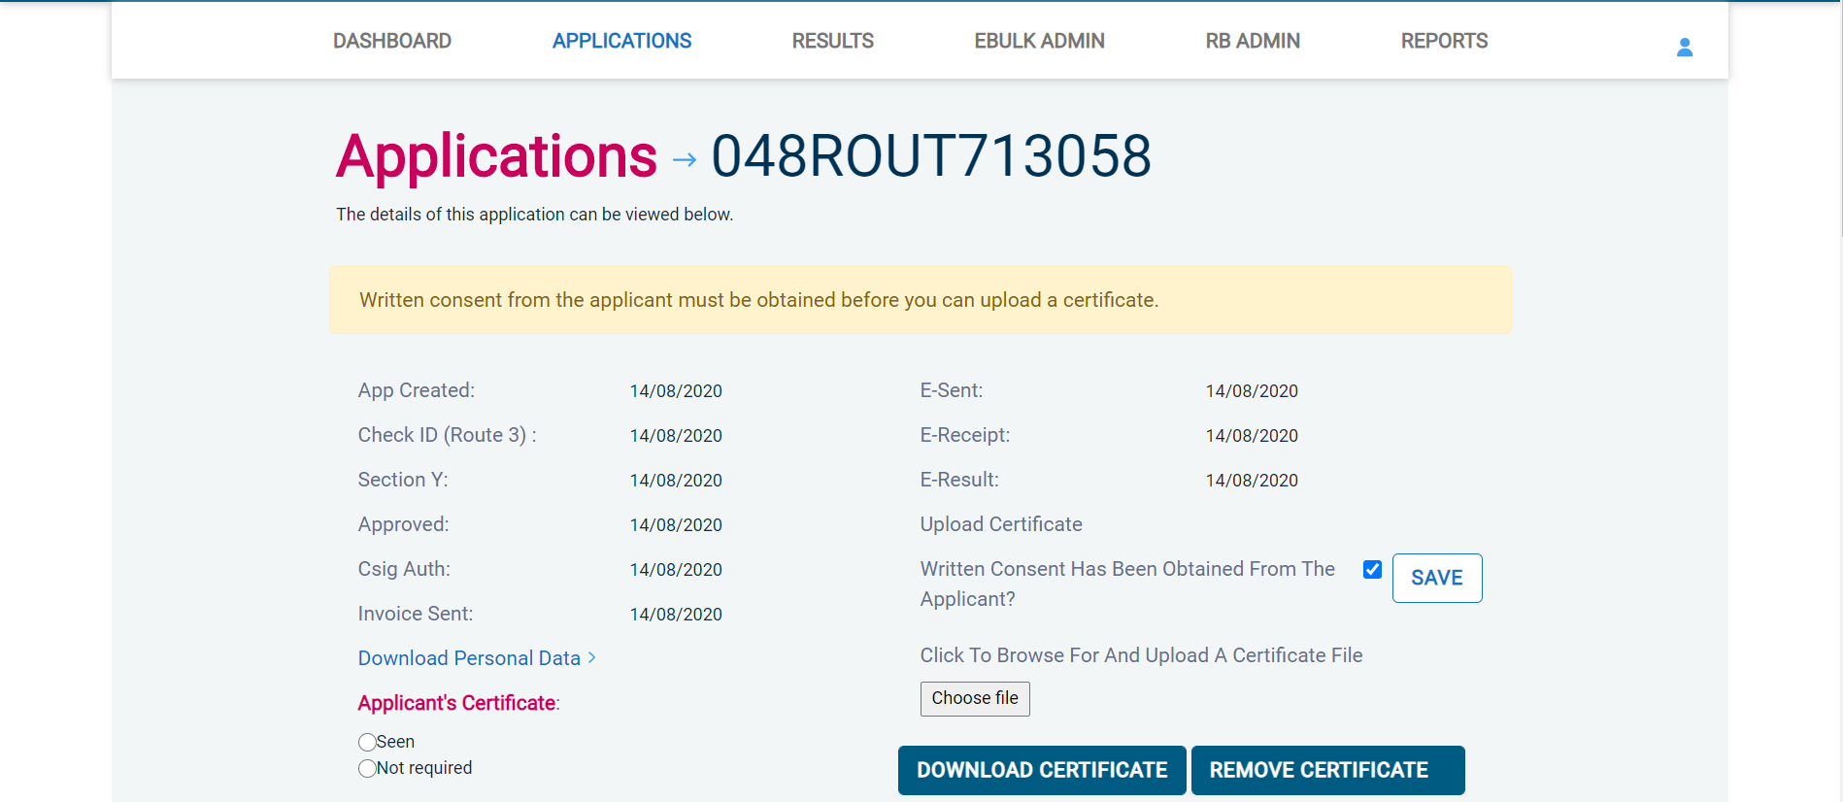
Screen Shot 31

Clear DBS results

Step 1 - Notification – refer back to screen shot 28 above.

- The DBS will send notification online once an application has been completed. To view a result please return to the Dashboard and click on ‘Completed’ in the Submitted section.

Step 2 - Viewing a clear certificate result– see screen shot 32.

- To view the information of a certificate e.g. certificate issue date, reference number and result status, click on the applicant’s reference number (see screen shot 32). This information will stay in the ‘Completed’ folder for 180 days from the issue date of the certificate.

- Clear certificate results will state “Certificate contains no information” in the status column – This means the certificate contains no criminal convictions, cautions, warnings or reprimands.

Screen Shot 32

Step 3 - Viewing a Result Snapshot for clear applications – see screen shots 32 & 33.

- As an Applicant Manager you can click on the ‘Certificate contains no information’ wording in the status column to view a Result Snapshot for this application (see screen shot 33 below).

Please note that the Result Snapshot is for information purposes only, it does not represent a DBS certificate or act as a DBS certificate alternative. The information contained within the snapshot is not to be viewed by or passed to any individual who does not have the appropriate authority to view it.

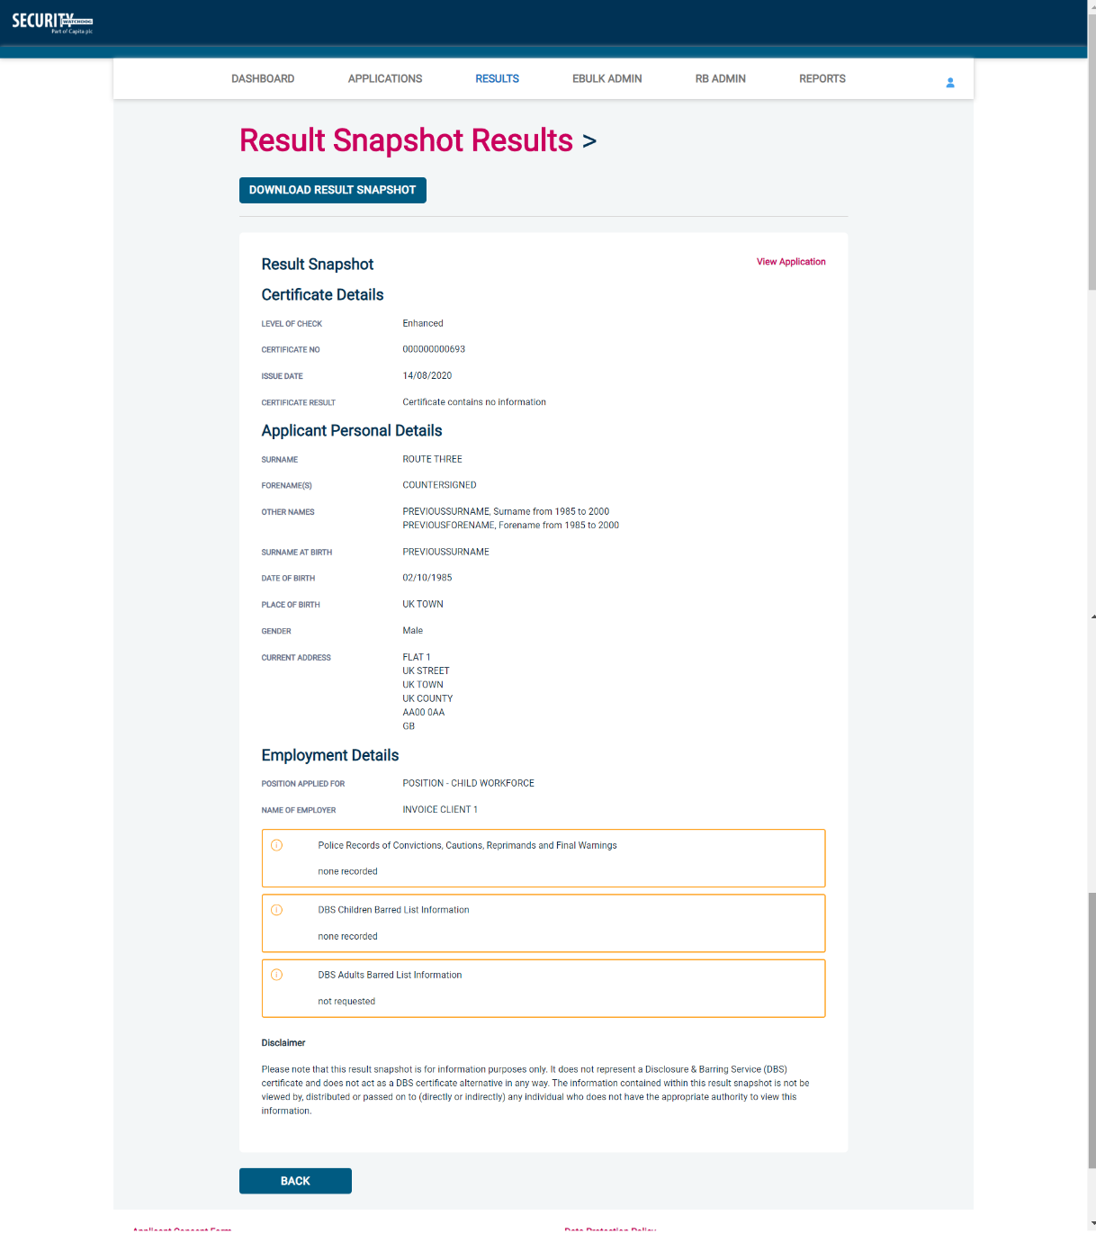
Screen Shot 33

As the Registered Body/Employer does not receive a copy of a completed DBS certificate, we advise that you have sight of the applicant’s certificate regardless of the status outcome on eBulkPlus; however, this is for your organisation to decide based on your own internal policies. For completed applications with a result status of “Please wait to view applicant’s certificate” you must view the applicant’s certificate before making a recruitment decision.

Right to Work application results

Step 1 - Notification – refer back to screen shot 28 above.

- An automated email will be issued once a digital Right to Work check has been completed. To view a result for a Right to Work application, please return to the Dashboard and click on ‘Completed’ in the Submitted section.

Step 2 - Viewing a Right to Work result– see screen shot 34.

- To view the result of the Right to Work check, click on the applicant’s reference number (see screen shot 34). This information will stay in the ‘Completed’ folder for 365 days from the issue date of the digital ID report. To download the full PDF report, click ‘Download Digital ID Report’ (see screen shot 35.)

- Digital Right to Work results will state one of the following results in the ‘Status’ column;

  - Pass – The applicant’s Right to Work has been successfully established
  - Fail – The applicant’s Right to Work has not been successfully established, you will need to download the Digital ID Report to understand why
  - See Report – The applicant’s Right to Work check has been carried out and involved a share code as the applicant is of non-UK origin. You will need to download the Digital ID Report to get the full detail of their Right to Work status

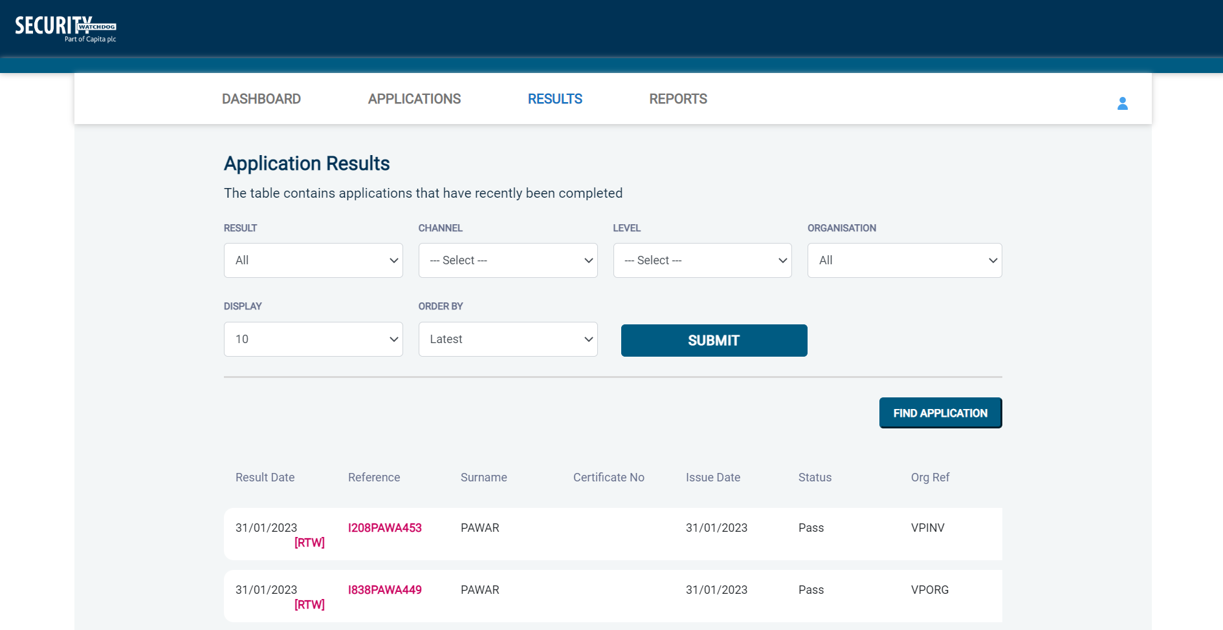
Screen Shot 34

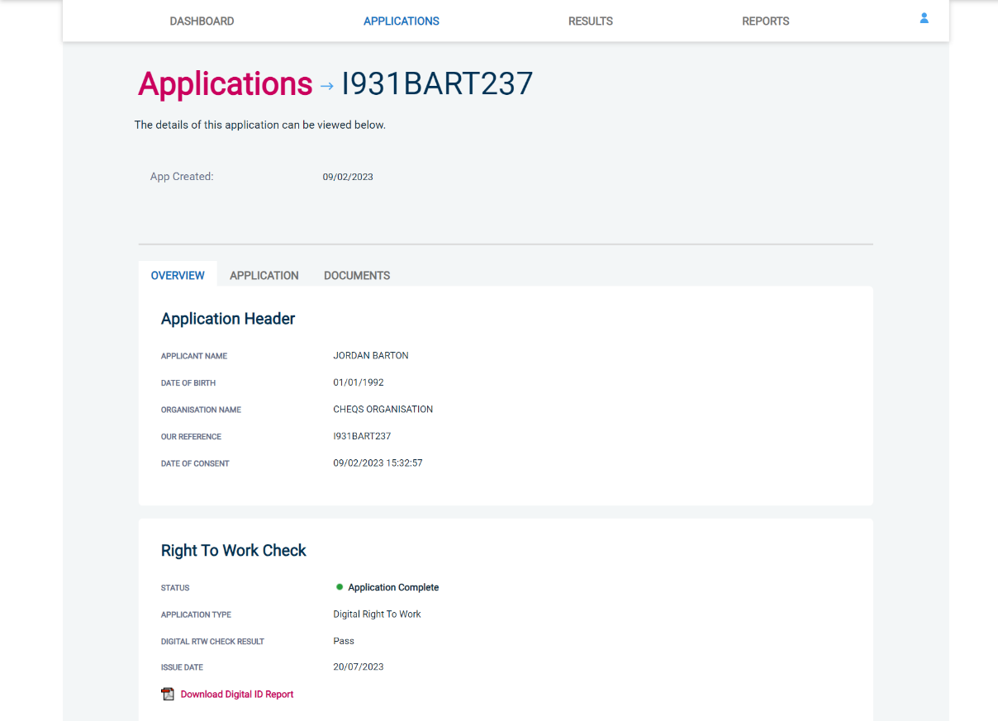
Screen Shot 35

Find an Application

Step 1 - Finding an individual application – see screen shots 36 & 37.

- To find an individual application pre or post processing or that has been archived, select from the Dashboard the Applications tab and then click on ‘Find Application’.

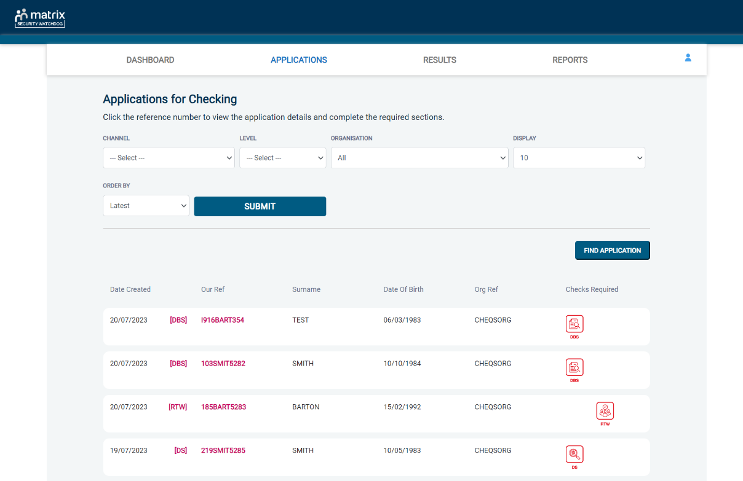
Screen Shot 36

- The following box will appear for you to enter as much of the applicant’s details as you have available. E.g. if you only enter the surname without date of birth or DBS reference, it will bring up a list of every applicant with that surname. However, if you enter their date of birth as well, then this will define the search results accordingly. If you tick the ‘Search Archived’ button, this will display applications that have been archived from the system.

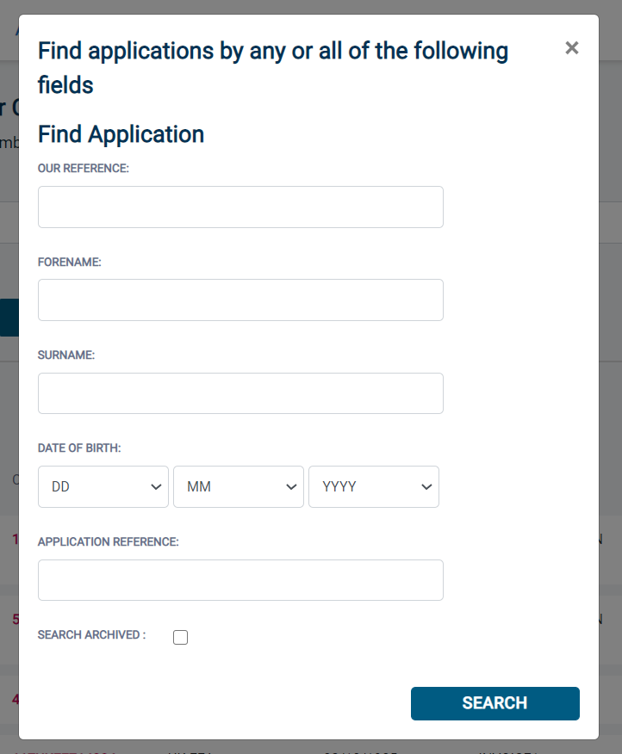
Screen Shot 37

Reports

Step 1 - Running a report – see screen shot 38.

- To run a report, you need to return to the Dashboard and select the tab ‘Reports’ and then select the report you wish to run. There are currently a number of standard reports that you can choose from, however it is also possible to run a customised report (please note that as you only process Standard/Enhanced DBS checks, you can ignore the right-hand section of the reports screen containing Basic Disclosure report information).

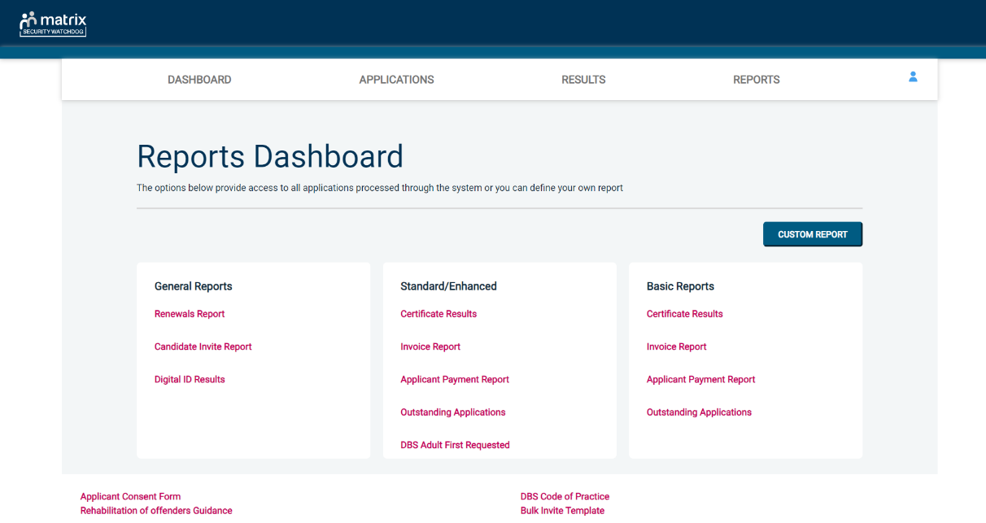
Screen Shot 38

Stage 2 – Invoice Report – see screen shot 38 above.

This report can be used to produce an electronic version of the invoice you will receive from us or for you to calculate the company budget required in relation to DBS costs. This can be filtered by a specific division or can be run on all divisions within your organisation. The report captures applicant and organisation data with the addition of;

- Basic, Standard or Enhanced Fee
- Cost Code
- Organisation Postcode
- Admin Fee (referred to as Base Fee on the system)
- VAT
- Total application price

Stage 3 - Customised Reports and selecting field headings – see screen shot 39.

- To run a customised report, you can select the field headings and date criteria that you wish the report to contain. For example, this is an ideal opportunity to run a report when carrying out re-checks on your staff or for capturing cost codes for invoicing purposes. All reports can be printed or saved into an Excel spreadsheet (.CSV file) or PDF document.

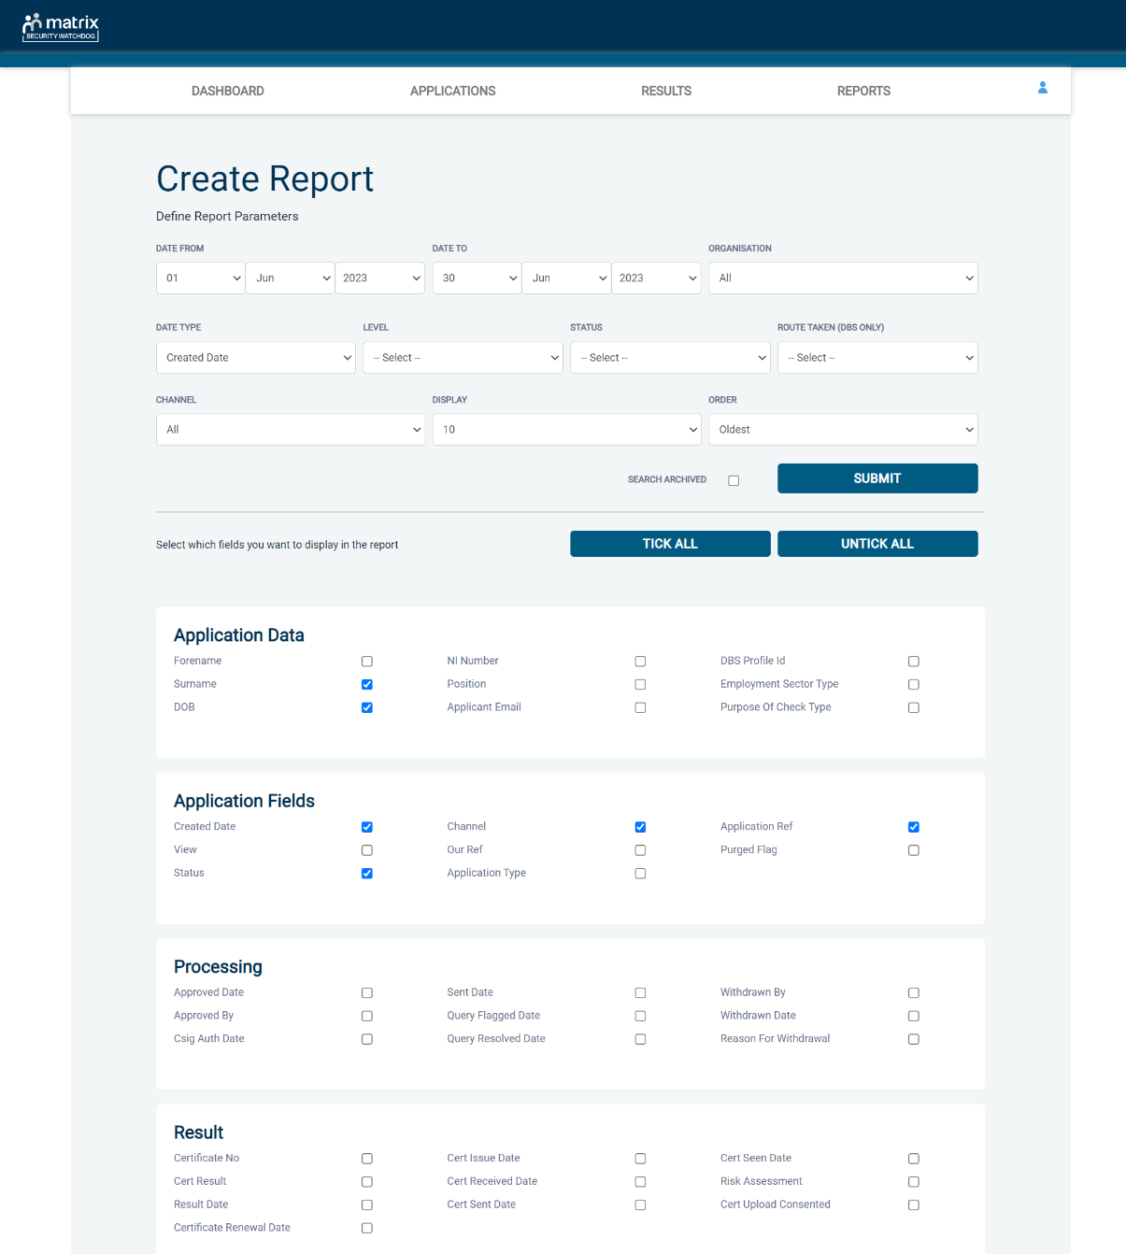
Screen Shot 39

ALL USERS – PLEASE LOG OFF AT THE END OF YOUR SESSION. IF A SESSION IS INACTIVE FOR MORE THAN TEN MINUTES YOU WILL BE AUTOMATICALLY LOGGED OFF FOR SECURITY REASONS.

CONTACT DETAILS

If you experience any technical issues with the online system, please contact XXX. Lines open 9.00am-5.30pm Monday to Friday. Alternatively, you can contact us by e-mail at XXX

DBS List of Acceptable Identification

Route 2
(3 documents to be seen plus an External ID Check)

1 document from Group 2a.
2 further documents from Group 2a or 2b.

Combination of documents must confirm name & DOB.

If unable to satisfy Route 2, proceed to Route 3/Fingerprints.

Route 1
(3 documents to be seen)

1 document from Group 1.
2 further documents from Group 1, 2a or 2b

Combination of documents must confirm name & DOB.

If unable to satisfy Route 1, proceed to Route 2/Fingerprints.
Route 3
(5 documents to be seen)

A UK Birth Certificate issued after birth.
4 further documents, 1 from Group 2a, 3 from 2a or 2b.

Combination of documents must confirm name & DOB.

If unable to satisfy Route 3, proceed to Fingerprints.

Fingerprints

Paper application form required (unable to process online).

Attendance at a local Police Station for fingerprints to be taken.

Group 1
Primary Identity Documents
- Current valid Passport
- Biometric Residence Permit (UK)
- Current Driving Licence – photo card (UK / Isle of Man / Channel Islands) (Full or Provisional)
- Birth Certificate (UK / Isle of Man / Channel Islands) (Issued within 12 months of birth)
Full or short form acceptable including those issued by UK authorities overseas, such as Embassies, High Commissions & HM Forces. (Photocopies are not acceptable)
- Adoption Certificate (UK / Channel Islands)
- eVisa - Accessed via the 'View and Prove' service
- Application Registration Card (ARC) – Issued by the Home Office

Group 2a  Trusted Government Documents | Group 2b  Financial & Social History Documents
- Current Driving Licence – photo card only (All Countries except Group 1) (Full or Provisional)  - Current Driving Licence – paper version (UK / Isle of Man / Channel Islands) (Full or Provisional)  - Birth Certificate (UK / Isle of Man / Channel Islands) (Issued after the time of birth)  - Marriage / Civil Partnership Certificate (UK / Channel Islands)  - HM Forces ID Card (UK)  - Fire Arms Licence (UK / Isle of Man / Channel Islands)  - Immigration document, work permit or VISA (Issued outside of UK) (Valid only for roles whereby applicant is living and working outside of UK.) | - Mortgage Statement (UK) **  - Bank/Building Society Statement (UK / Channel Islands) *  Monzo statements or statements printed from the internet are not acceptable  - Bank/Building Society Account Opening Confirmation Letter (UK) *  - Credit Card Statement (UK) *  - Financial Statement e.g. pension, endowment, ISA (UK) **  - P45/P60 Statement (UK / Channel Islands) **  - Council Tax Statement (UK / Channel Islands) **  - Utility Bill (UK) - Not Mobile Phone *  - Benefit Statement (UK) e.g. Child Allowance, Pension **  - Document from Central/ Local Government/ Government Agency/ Local Authority giving entitlement (UK / Channel Islands) *  e.g. DWP, Employment Service, HMRC, Job Centre, Social Security  - EEA National ID Card – must be valid  - Cards carrying the PASS accreditation logo (UK / Isle of Man / Channel Islands) – must be valid  - Irish Passport Card – must be valid (Cannot be used with an Irish Passport)  - Letter from Head Teacher or College Principal (16-19 year olds in full time education in the UK)  - Non-UK Bank/Building Society Statement *  Branch must be located in the country in which the applicant lives and works  - Letter of Sponsorship from future employer  Non-UK only – valid only for applicants residing outside UK at time of application  - HMRC self-assessment letters/tax demand letter (UK) **  - Valid European Health Insurance Card (EHIC) / Global Health Insurance Card (GHIC) (UK)
Please note if a document in the List of Valid Identity Documents is:
- Denoted with * - issued in the last 3 months
- Denoted with ** - issued in the last 12 months

