ID Checker Guidance Notes

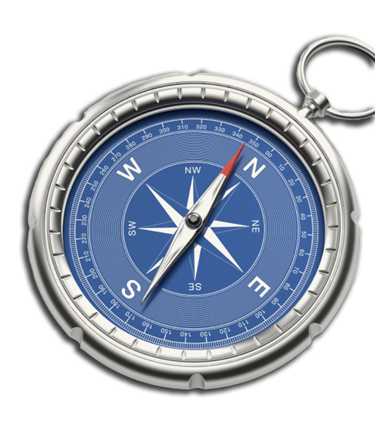
DBS Online Disclosure Guide (eBulkPlus)

Contents
ID Checker Guidance Notes 1
Logging onto the System 2-5
How to verify ID 6-9
Find an application 10
DBS List of Acceptable Identification 11

ID Checker Guidance Notes

Online Disclosure and Barring Service (DBS) checks can be completed by accessing the internet from any device that has this facility. This includes a smart phone, tablet, laptop or PC. It is supported on the latest versions of all modern browsers; however, we do not recommend access via Internet Explorer as this browser is unsupported both by our technology and soon by Microsoft also.

You have been granted access to eBulkPlus in the role of an ID Checker. An ID Checker can view all applications created under the organisation or specific division they have been created under. The ID Checker can stipulate what ID has been seen in relation to an applicant. The ID Checker will then need to advise an Applicant Manager or Countersignatory (where applicable) within their organisation or division to complete the Section Y details and approve the application for countersigning.

Logging onto the System

Please enter the following address into your web browser:
https://matrixscreening.com/xxxxx

You will now be on the main login page that shows three white boxes. NB *Please note at this stage of the process, your login details are case sensitive.

Step 1. Click on ‘Application Management’, this will take you to the start of the application process.

- Enter your company Organisation Reference - this will have been supplied to you in an automated email (if you cannot remember this please click on the ‘Forgotten your login details?’ icon at the bottom of the screen to be sent a reminder).
- Enter your Username.
- Enter your Date of Birth (for first initial login please ensure you enter the default date of birth 01 Jan 1998. Failure to do so will deny you access to the system).

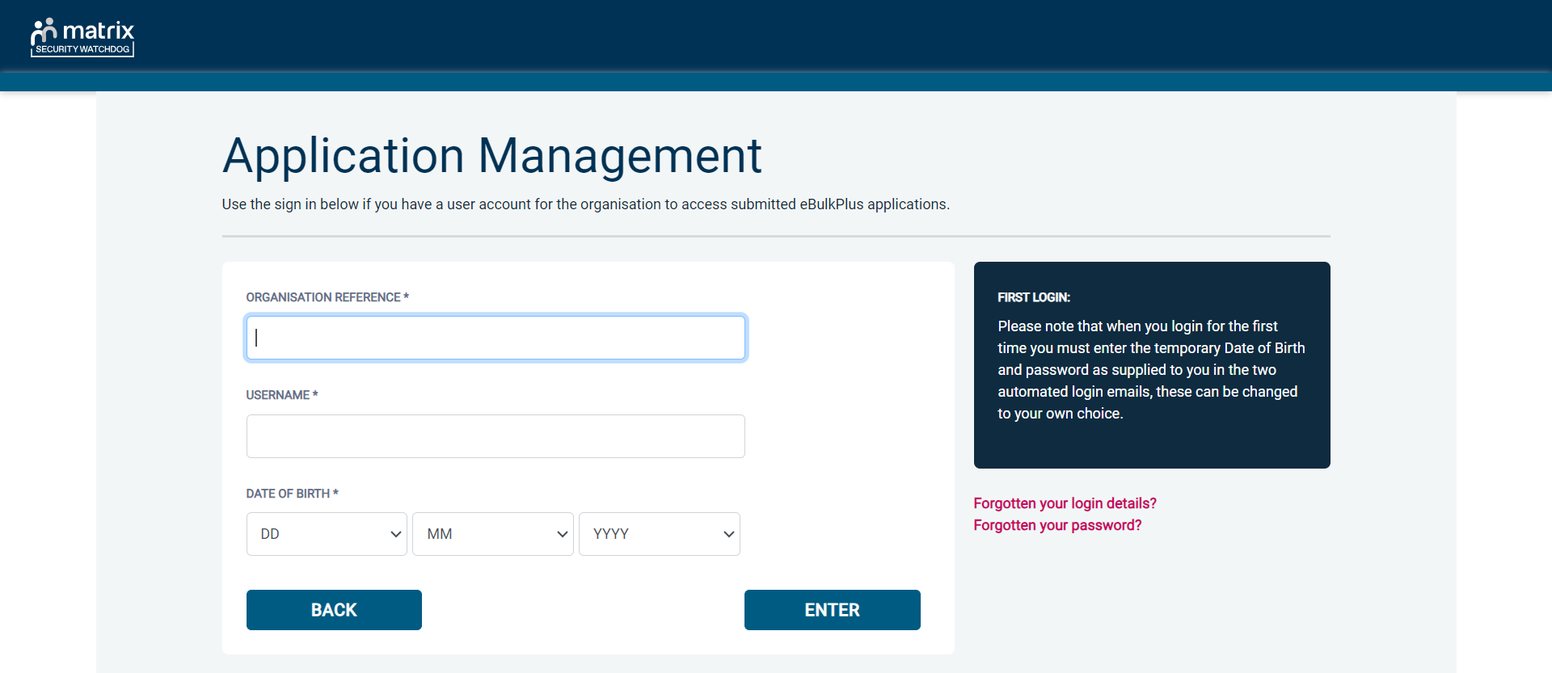
Screen Shot 1

- Once you have completed this section click ‘Enter’.
- Enter your password (this will be supplied to you in an automated email) – see screen shot 2. (If you cannot remember this please click on the ‘Forgotten your password?’ icon at the bottom of the screen to be sent a new one-time password).

If you still have difficulty gaining access to the system please contact XXX, however please ensure the first time you login that you have not been denied access because of entering your own date of birth. The first time you login you must enter the temporary default date of birth 01 Jan 1998.

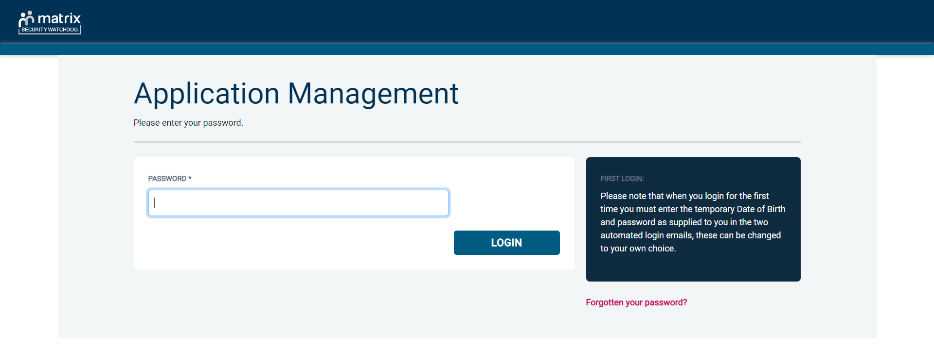
Screen Shot 2

- Please note, after initial login you will be required to set your own password and enter your own date of birth for future login purposes.
- Please re-enter into the ‘Current Password’ field the temporary password you received in your initial e-mail and then create your own unique password – see screen shot 3 below.
- The password you create must be between 8 & 30 characters containing at least one upper case letter, one lower case letter, one special character and at least one number.
- Please then enter a date of birth of your choice for future login purposes.

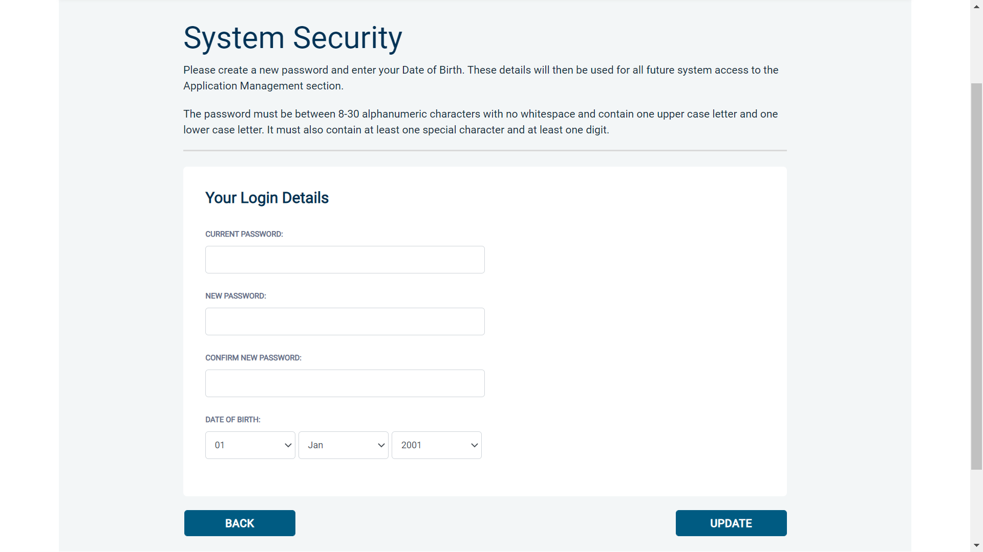
Screen Shot 3

- Please then click ‘Update’.

- If you have successfully created your own password, you will now be able to enter the system by clicking the ‘Click here to enter System’ icon in the green box.


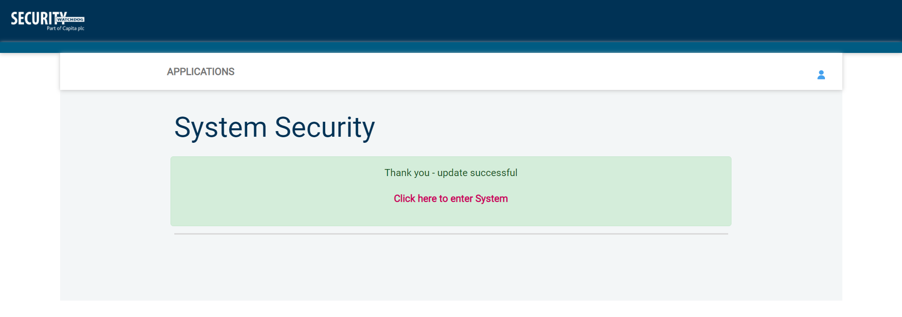

Screen Shot 4

- This will now take you to the eBulkPlus dashboard containing a list of ‘Applications for ID Checking’.

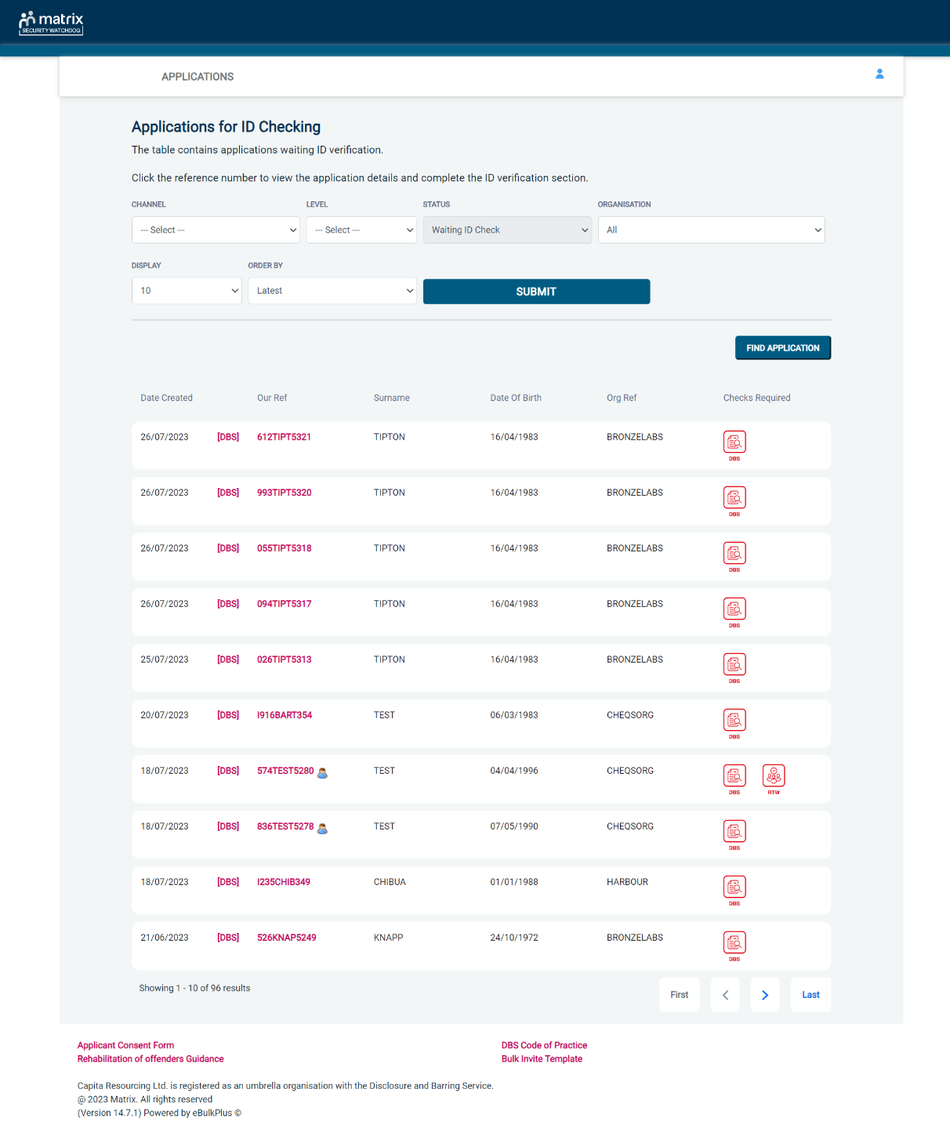
Screen Shot 5

How to verify ID

Step 1 - On the Applications page, click on the relevant applicant’s reference number to open up the application form (see screen shot 6 below).

Screen Shot 6

Step 2 - Application Form, you will now see two tabs of the applicant’s completed form. Overview and Application (screen shots 7 & 8).

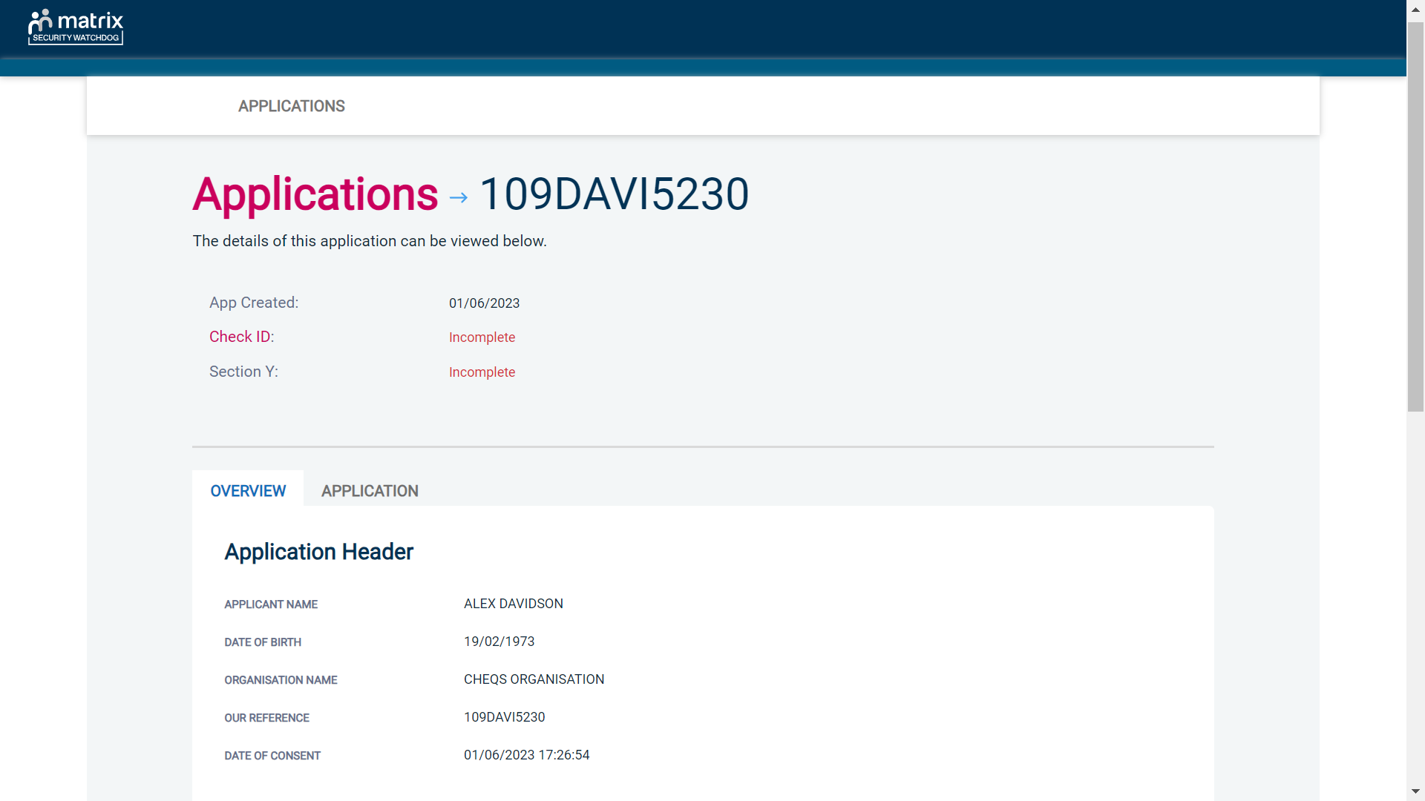
Screen Shot 7
Step 3 – Application, to view the application details entered by the applicant, click on the ‘Application’ tab. Here you can see the entire application submitted by the applicant, this can be used to ensure the correct job role has been entered and to verify any ID given by the applicant in a previous surname or previous address (see screen shot 8).

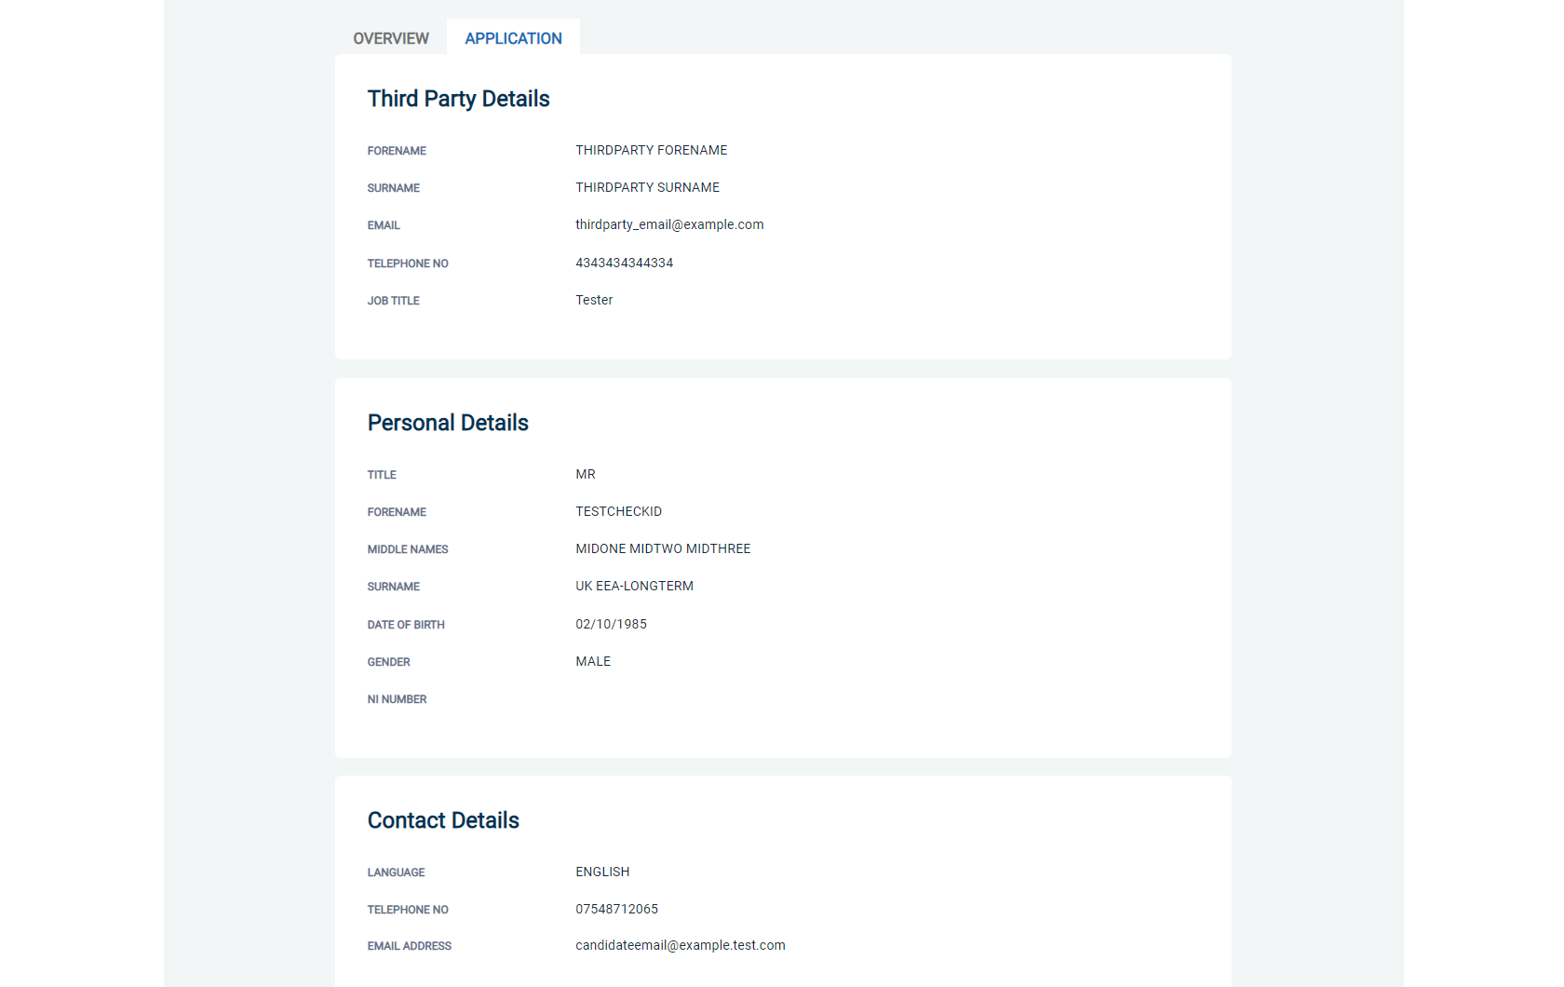
Screen Shot 8

Step 4 - Verifying ID

- You will notice at the top of the screen a box which highlights if the ID has been verified or not (see screen shot 7 above), with a section completion date. It will say in red ‘Incomplete’ if the section has not been completed for either ID verification or Section Y. If there is a date entered it means that this action has been completed and will show the date that it was carried out on.

- To complete the ID verification section, click on ‘Check ID’ (see screen shot 7 above), access to this section is located in two places – at the top of the screen or on the overview of the actual form itself. You will now be on the ID screen (see screen shot 9 below).


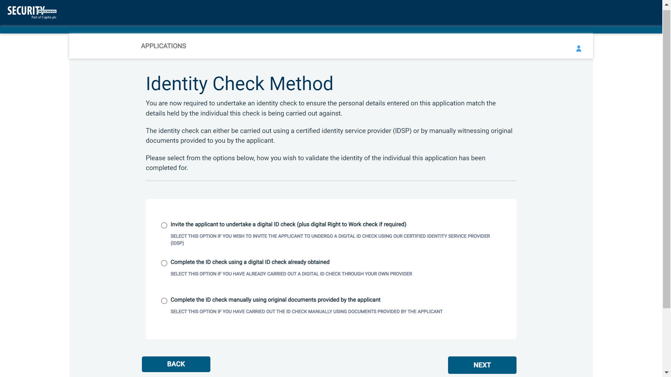
Screen Shot 9

Verifying identity using the eBulk digital ID integration

This facility allows for the identity verification to be performed digitally and remotely without the need for the applicant to present original documents to you to be verified. It also allows you to request a digital Right to Work check at the same time as performing the identity verification digitally. If you wish to carry out the identity check using our certified identity service provider, please select ‘Invite the applicant to undertake a digital ID check (plus digital Right to Work check if required)’ (see screen shot 9 above.)

You will now be taken to the digital invite page which will automatically populate the name and email address of the applicant where present (see screen shot 10 below.) To invite the applicant to undertake just a digital ID check, please select ‘Digital ID Check Only’ from the ‘Digital ID Check Type’ drop-down list and ensure their name and email address are populated along with selecting the email template to issue them. This will generate an email to the applicant allowing them to carry out their digital ID check via our certified IDSP.

To invite the applicant to undertake a digital ID check and a digital Right to Work Check, please select ‘Right to Work + Digital ID Check’ from the ‘Digital ID Check Type’ drop-down list and ensure their name and email address are populated along with selecting the email template to issue them. This will generate an email to the applicant allowing them to carry out their digital ID check and digital Right to Work check at the same time via our certified IDSP.


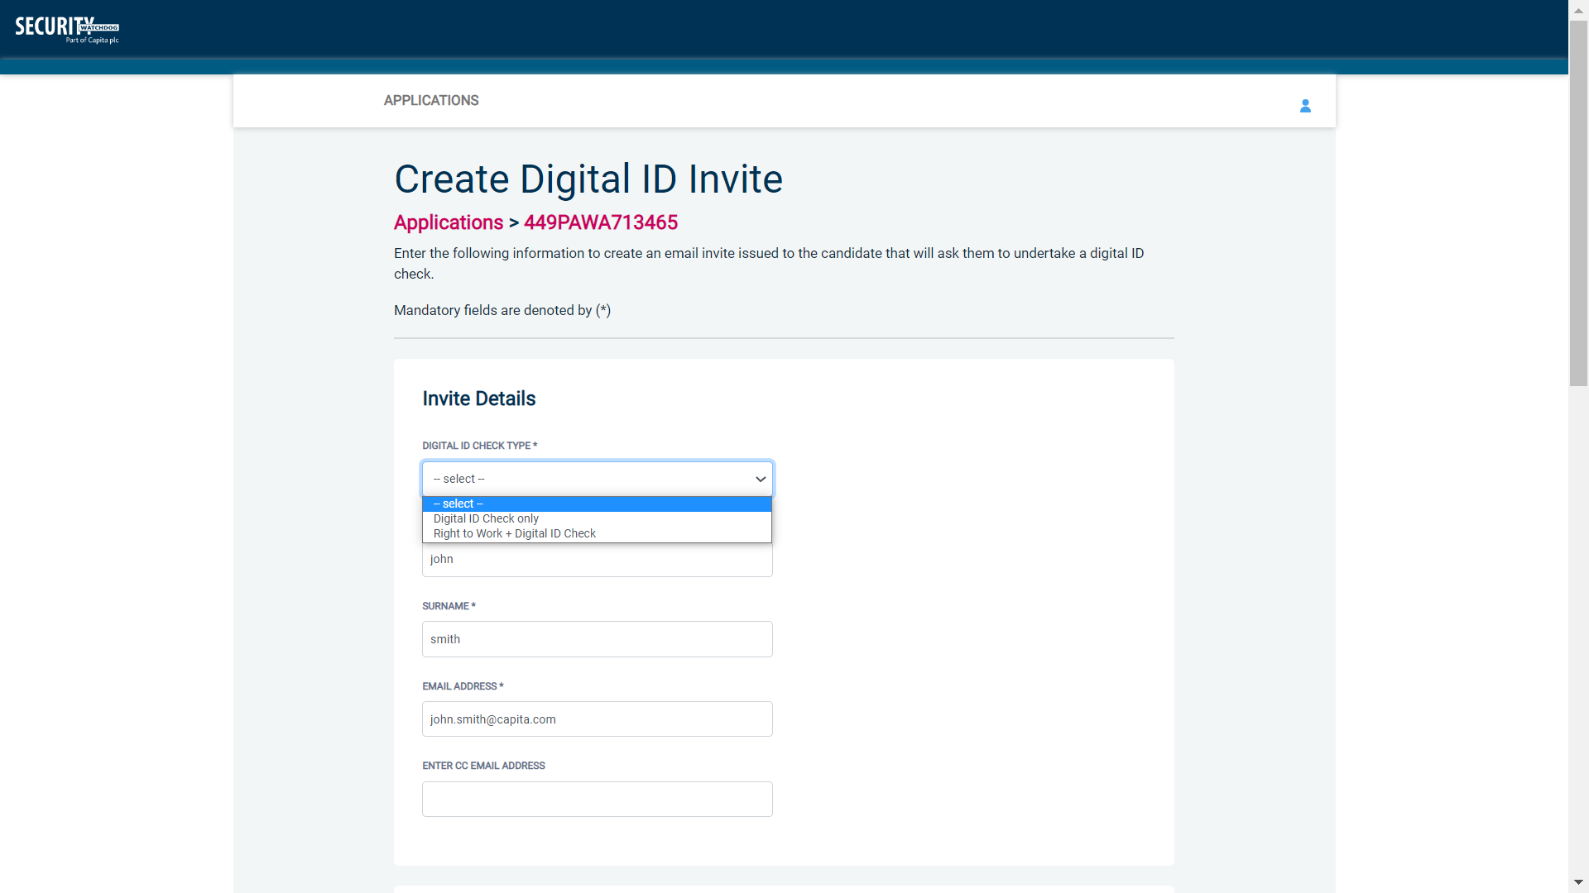
Screen Shot 10

Once the digital ID check has been carried out, the ID section of the application will be updated with either a pass or fail result and a PDF report of the digital ID check can be downloaded by clicking the ‘Download Digital ID Report’ button (see screen shots 11 & 12 below.)

If the result of the digital ID check is ‘FAIL’, you must read the digital ID report to understand why and verify their identity manually depending on the reason the digital ID check failed. To do this, click the ‘RESET ID CHECK’ button at the bottom of the ID screen to restart the identity process, this time selecting an alternative method.

If the result of the digital ID check is ‘PASS’, the ID section will be auto completed upon receipt of the digital ID check result and there will be nothing further to do in relating to the identity verification part of the process.

If a digital Right to Work check was also requested, a ‘RTW Check’ element will be added to the header of the application and will be updated with either a pass, fail or see report result and a PDF report of the digital Right to Work check can be downloaded by clicking the ‘Download Digital ID Report’ button from either the ID screen or the RTW screen.

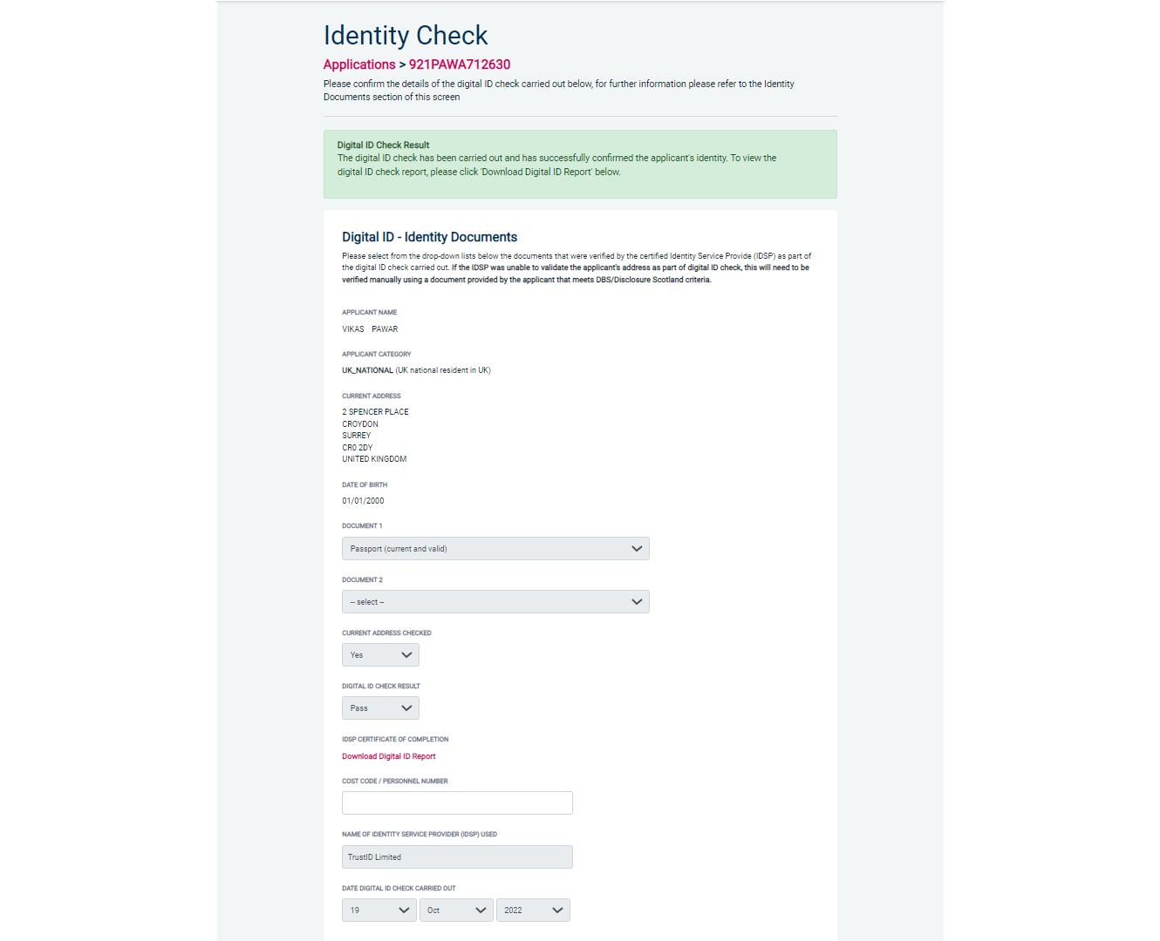
Screen Shot 11

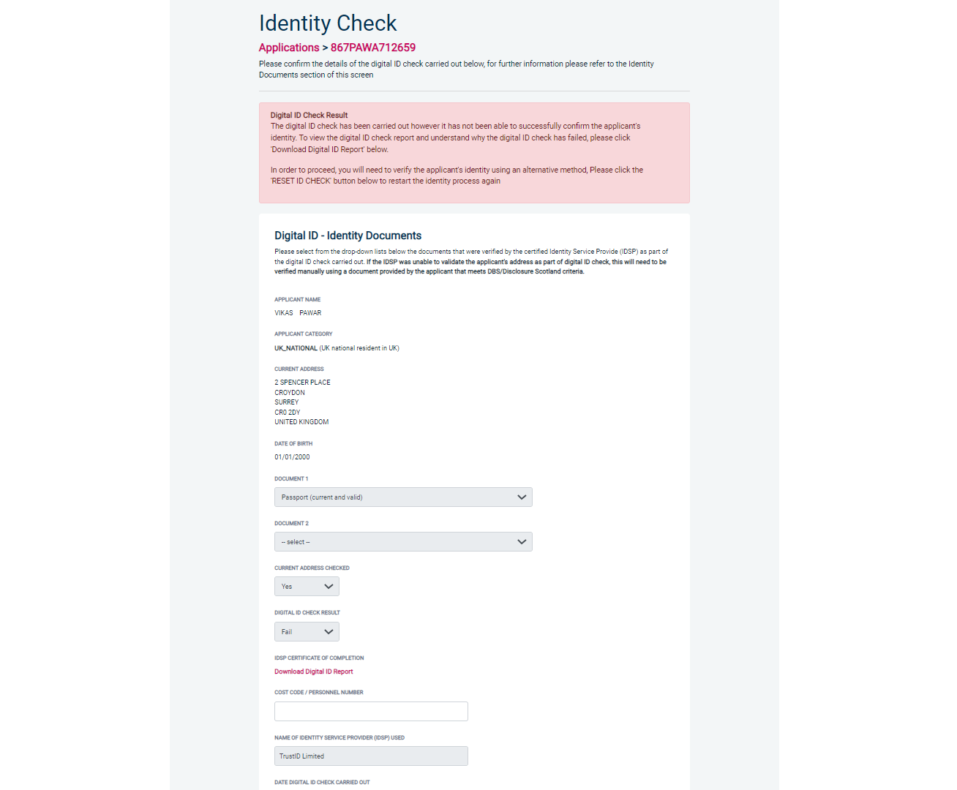
Screen Shot 12

Verifying identity using a digital ID check already obtained

This facility allows you to verify the identity using a digital ID check already obtained via your own IDSP outside of our platform. If you wish to verify the identity using this method, please select ‘Complete the ID check using a digital ID check already obtained’ (see screen shot 9 above and screen shot 13 below.)

- Please select the ID documents verified by the IDSP as part of the digital ID check undertaken.
- Ensure that you confirm from the drop-down boxes that they have verified the applicant’s address and also that they have verified a document containing their date of birth.
- Please upload a copy of the digital ID report obtained from your IDSP by clicking ‘Choose File’
- If a Cost Code or Personnel Number is required to be assigned to the specific application, this can be entered in the Cost Code / Personnel Number field.
- Now click ‘Save’ and then click the ‘Return to Application’ icon in the green box located at the top of the screen. Now you are ready to complete Section Y of the form (this is the equivalent to Section X on the new lilac paper DBS application forms).
- Once the ID Check has been saved, if you realise that it has been completed incorrectly or through the wrong route, you can reset the ID Check section and complete it again if required. Please note, you will only be able to do this if you have been assigned the appropriate user privilege to do so. To do this, go back into the ID Check screen and click the ‘Reset ID Check’ button found at the bottom of the screen.

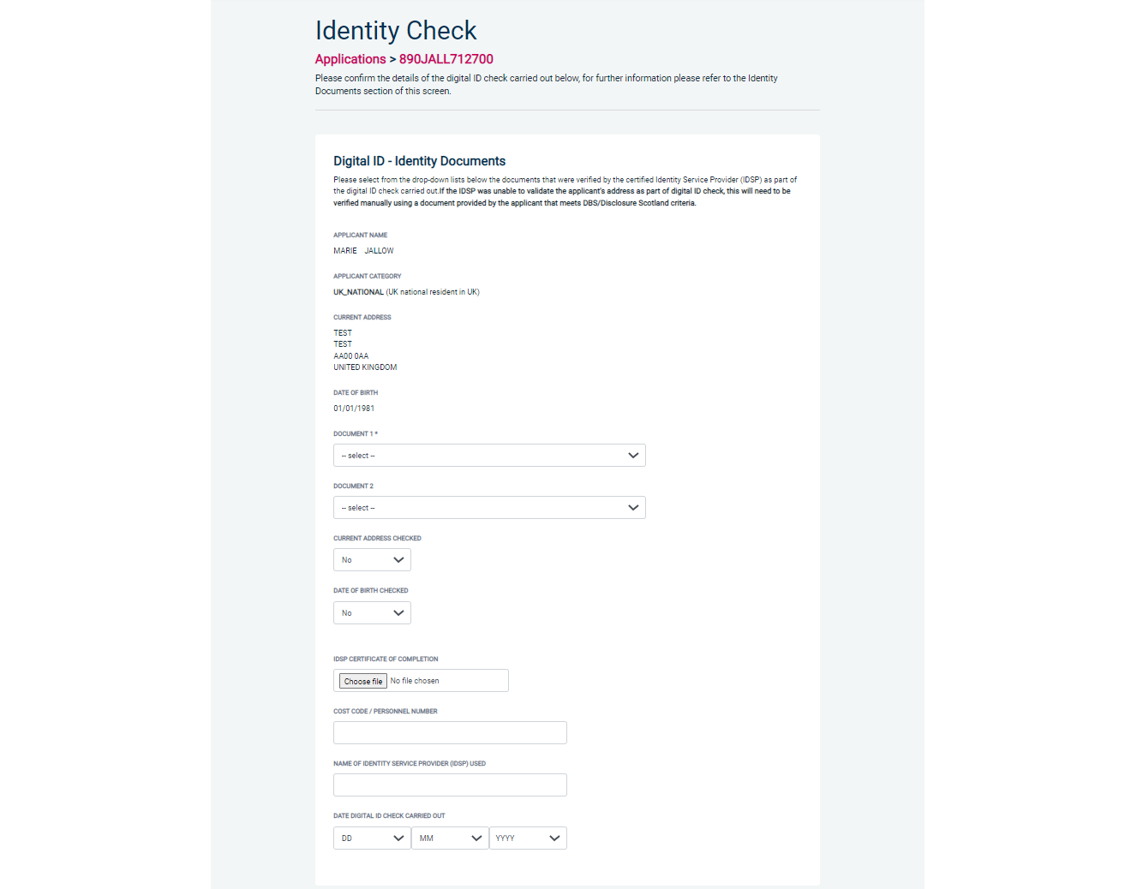
Screen Shot 13

Verifying identity using original documents provided to you by the applicant

If you do not wish to verify identity using a digital ID check, please select ‘Complete the ID check manually using original documents provided by the applicant’ (see screen shot 9 above and screen shot 14 below.)

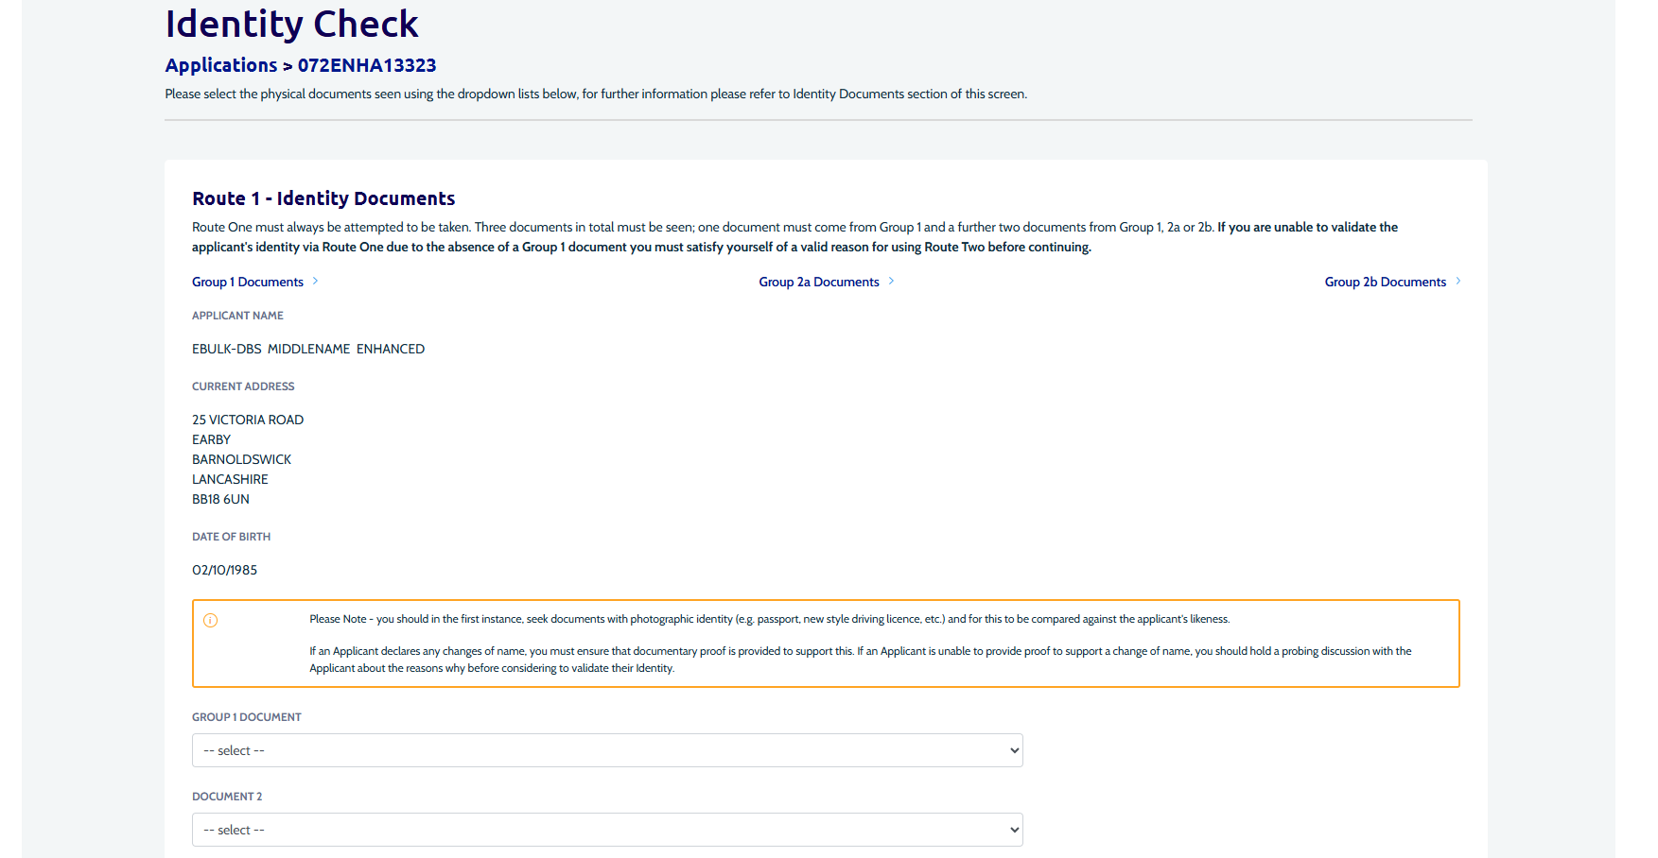
Screen Shot 14

eBulkPlus will automatically commence with Route 1, assuming that the applicant has the appropriate documents required for Route 1. If an applicant does not hold sufficient ID to be able to go through Route 1, you will be required to click the ‘Next Route’ button at the bottom of the screen.

- Please select the ID the applicant has provided for you from the drop down boxes. Guidance notes can be found at the top of the screen and are in accordance with the DBS Code of Practice. Please ensure at all times that you follow the ID checking rules e.g. do not accept a utility bill if it is more than 3 months old or do not accept an out of date passport.
- Ensure you confirm that you have verified a document showing the applicant’s date of birth.
- If a Cost Code or Personnel Number is required to be assigned to the specific application, this can be entered in the Cost Code / Personnel Number field.
- Now click ‘Save’ and then click the ‘Return to Application’ icon in the green box located at the top of the screen. Now you are ready to complete Section Y of the form (this is the equivalent to Section X on the new lilac paper DBS application forms).

Please note, that if an applicant cannot verify their identity via Routes 1, 2 or 3 they will not be able to process their application through eBulk and will need to complete a paper application stating ‘NO’ in section W59. Fingerprints will need to be taken and consent will be required by the applicant.

*A full list of DBS acceptable ID for each route can be found at the end of this guide*

What you must do as part of the ID Checking process

When verifying identity manually, the applicant must provide a range of ID documents as part of the DBS check application process. As an employer you must:
- Make sure that any details of current passport, driving licence and National Insurance Number are included on the paper or electronic application form.
- Follow the three route ID checking guidance set out below.
- Consider using digital ID verification if the applicant can present a passport or driving licence.
- Seek photographic identity documents (passport, driving licence, e-Visa or PASS card) in the first instance. This can be used to compare the applicant’s likeness. Check and validate the information provided on the application form by the applicant.
- Check that the application form is completed in full and the information it contains is accurate. For example, that all addresses lived at in the last 5 years and names known by have been declared and are accurate. Failure to do this can result in delays in processing and the withdrawal of applications.
- Make sure the applicant fills in the address part of the form correctly if they have an unusual address, for example if they live abroad, in student accommodation or a hostel.
- Use a document type only once in the document count. For example, don’t accept two bank statements as two of the required documents if they are from the same bank.
- Not alter or amend the application form without the knowledge or agreement of the applicant.
- Keep a record of the documents used to validate each identity for a minimum of 2 years. This is in line with compliance activity carried out by DBS. DBS will ask for records of documents checked as part of ID verification as part of this process. Documents can be recorded as copies of physical documents or PDF evidence of eVisa. If it is not possible to keep copies you should record:
  - document type,
  - country of issue
  - any expiry date,
  - any reference numbers, and
  - notes if there were any discrepancies discussed as part of the ID verification process.
- Verify their identity in accordance with the three ways in which ID documents can be viewed and validated. You must use option one unless it is impossible to have a face-to-face appointment with the applicant. If you are unable to use option one the reasons need to be recorded and option two can be considered. If option two is impossible the reasons must be recorded and option three can be used. The rationale behind the use of options two or three must be kept, along with a record of the documents used to validate the identity, for a minimum of 2 years.
  - Option One: The ID check should be done in person, allowing the ID checker to view the physical documents, or eVisa, or digital PASS card, in the presence of the individual. If you cannot use option 1, please consider using digital identity verification before considering option 2.
  - Option Two: The ID checker can conduct the ID check via video link – for example Google Meet or FaceTime. In these circumstances the ID checker must be in possession of the physical documents. These can be posted to the ID checker in advance of the virtual call. Any risks identified when using live video must be assessed and mitigated by you. You must not rely on the inspection of the documents via a live video link, or by checking a faxed or scanned copy of the document. If option two is used, you must keep a record of why option one was impossible, along with a record of the documents used to validate the identity, for a minimum of 2 years. The rationale must be specific to the individual ID verification, it is not acceptable to default to the use of options two or three.
  - Option Three: The ID check can be completed via video link – for example Google Meet or FaceTime – without the ID checker being in physical possession of the ID documents. The details of the documents, as set out above, must be recorded and stored at the time of the video link ID check. The documents must be presented to the ID checker on the first day of employment. The ID checker must record the date the ID check was completed in person and cross reference the details recorded from the video link ID check. If there are any discrepancies the DBS check may be invalid. If option three is used you must keep a record of why options one and option two were impossible, along with a record of the documents used to validate the identity, for a minimum of 2 years. The rationale must be specific to the individual ID verification, it is not acceptable to default to the use of options two or three.

Find an Application

Step 1 - Finding an individual application – see screen shots 15 & 16.

- To find an individual application from the list of applications that require identity verification, please click on ‘Find Application’

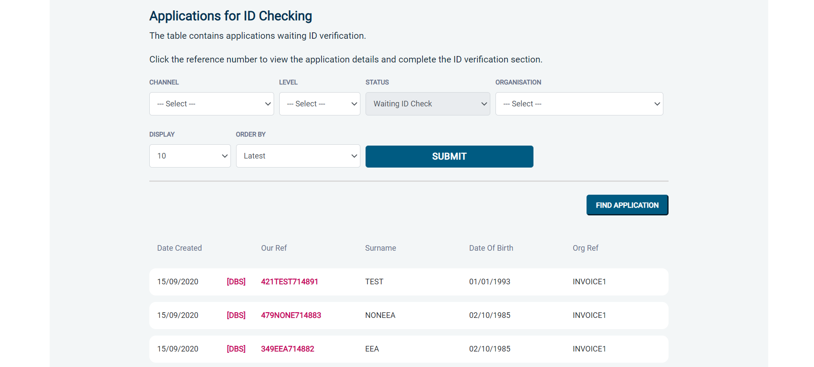
Screen Shot 15

- The following box will appear for you to enter as much of the applicant’s details as you have available. E.g. if you only enter the surname without date of birth or DBS reference, it will bring up a list of every applicant with that surname. However, if you enter their date of birth as well, then this will define the search results accordingly.

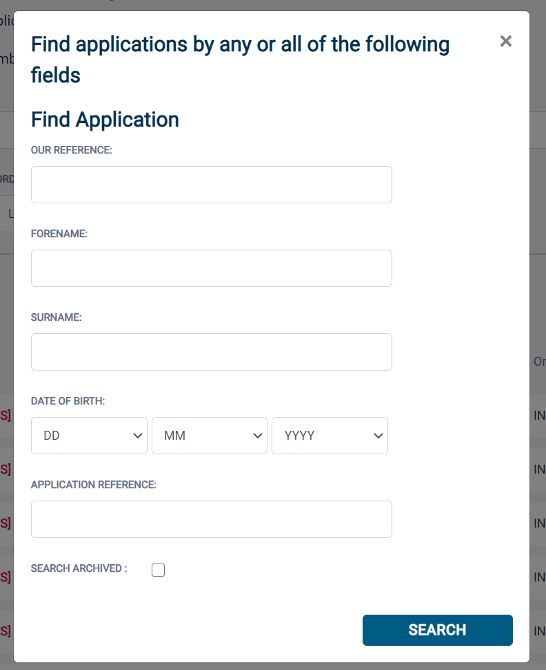

ALL USERS – PLEASE LOG OFF AT THE END OF YOUR SESSION. IF A SESSION IS INACTIVE FOR MORE THAN TEN MINUTES YOU WILL BE AUTOMATICALLY LOGGED OFF FOR SECURITY REASONS.

CONTACT DETAILS

If you experience any technical issues with the online system, please contact XXX. Lines open 9.00am-5.30pm Monday to Friday. Alternatively, you can contact us by e-mail at XXX

DBS List of Acceptable Identification

Route 2
(3 documents to be seen plus an External ID Check)

1 document from Group 2a.
2 further documents from Group 2a or 2b.

Combination of documents must confirm name & DOB.

If unable to satisfy Route 2, proceed to Route 3/Fingerprints.

Route 1
(3 documents to be seen)

1 document from Group 1.
2 further documents from Group 1, 2a or 2b

Combination of documents must confirm name & DOB.

If unable to satisfy Route 1, proceed to Route 2/Fingerprints.
Route 3
(5 documents to be seen)

A UK Birth Certificate issued after birth.
4 further documents, 1 from Group 2a, 3 from 2a or 2b.

Combination of documents must confirm name & DOB.

If unable to satisfy Route 3, proceed to Fingerprints.

Fingerprints

Paper application form required (unable to process online).

Attendance at a local Police Station for fingerprints to be taken.

Group 1
Primary Identity Documents
- Current valid Passport
- Biometric Residence Permit (UK)
- Current Driving Licence – photo card (UK / Isle of Man / Channel Islands) (Full or Provisional)
- Birth Certificate (UK / Isle of Man / Channel Islands) (Issued within 12 months of birth)
Full or short form acceptable including those issued by UK authorities overseas, such as Embassies, High Commissions & HM Forces. (Photocopies are not acceptable)
- Adoption Certificate (UK / Channel Islands)
- eVisa - Accessed via the 'View and Prove' service
- Application Registration Card (ARC) – Issued by the Home Office

Group 2a  Trusted Government Documents | Group 2b  Financial & Social History Documents
- Current Driving Licence – photo card only (All Countries except Group 1) (Full or Provisional)  - Current Driving Licence – paper version (UK / Isle of Man / Channel Islands) (Full or Provisional)  - Birth Certificate (UK / Isle of Man / Channel Islands) (Issued after the time of birth)  - Marriage / Civil Partnership Certificate (UK / Channel Islands)  - HM Forces ID Card (UK)  - Fire Arms Licence (UK / Isle of Man / Channel Islands)  - Immigration document, work permit or VISA (Issued outside of UK) (Valid only for roles whereby applicant is living and working outside of UK.) | - Mortgage Statement (UK) **  - Bank/Building Society Statement (UK / Channel Islands) *  Monzo statements or statements printed from the internet are not acceptable  - Bank/Building Society Account Opening Confirmation Letter (UK) *  - Credit Card Statement (UK) *  - Financial Statement e.g. pension, endowment, ISA (UK) **  - P45/P60 Statement (UK / Channel Islands) **  - Council Tax Statement (UK / Channel Islands) **  - Utility Bill (UK) - Not Mobile Phone *  - Benefit Statement (UK) e.g. Child Allowance, Pension **  - Document from Central/ Local Government/ Government Agency/ Local Authority giving entitlement (UK / Channel Islands) *  e.g. DWP, Employment Service, HMRC, Job Centre, Social Security  - EEA National ID Card – must be valid  - Cards carrying the PASS accreditation logo (UK / Isle of Man / Channel Islands) – must be valid  - Irish Passport Card – must be valid (Cannot be used with an Irish Passport)  - Letter from Head Teacher or College Principal (16-19 year olds in full time education in the UK)  - Non-UK Bank/Building Society Statement *  Branch must be located in the country in which the applicant lives and works  - Letter of Sponsorship from future employer  Non-UK only – valid only for applicants residing outside UK at time of application  - HMRC self-assessment letters/tax demand letter (UK) **  - Valid European Health Insurance Card (EHIC) / Global Health Insurance Card (GHIC) (UK)
Please note if a document in the List of Valid Identity Documents is:
- Denoted with * - issued in the last 3 months
- Denoted with ** - issued in the last 12 months

